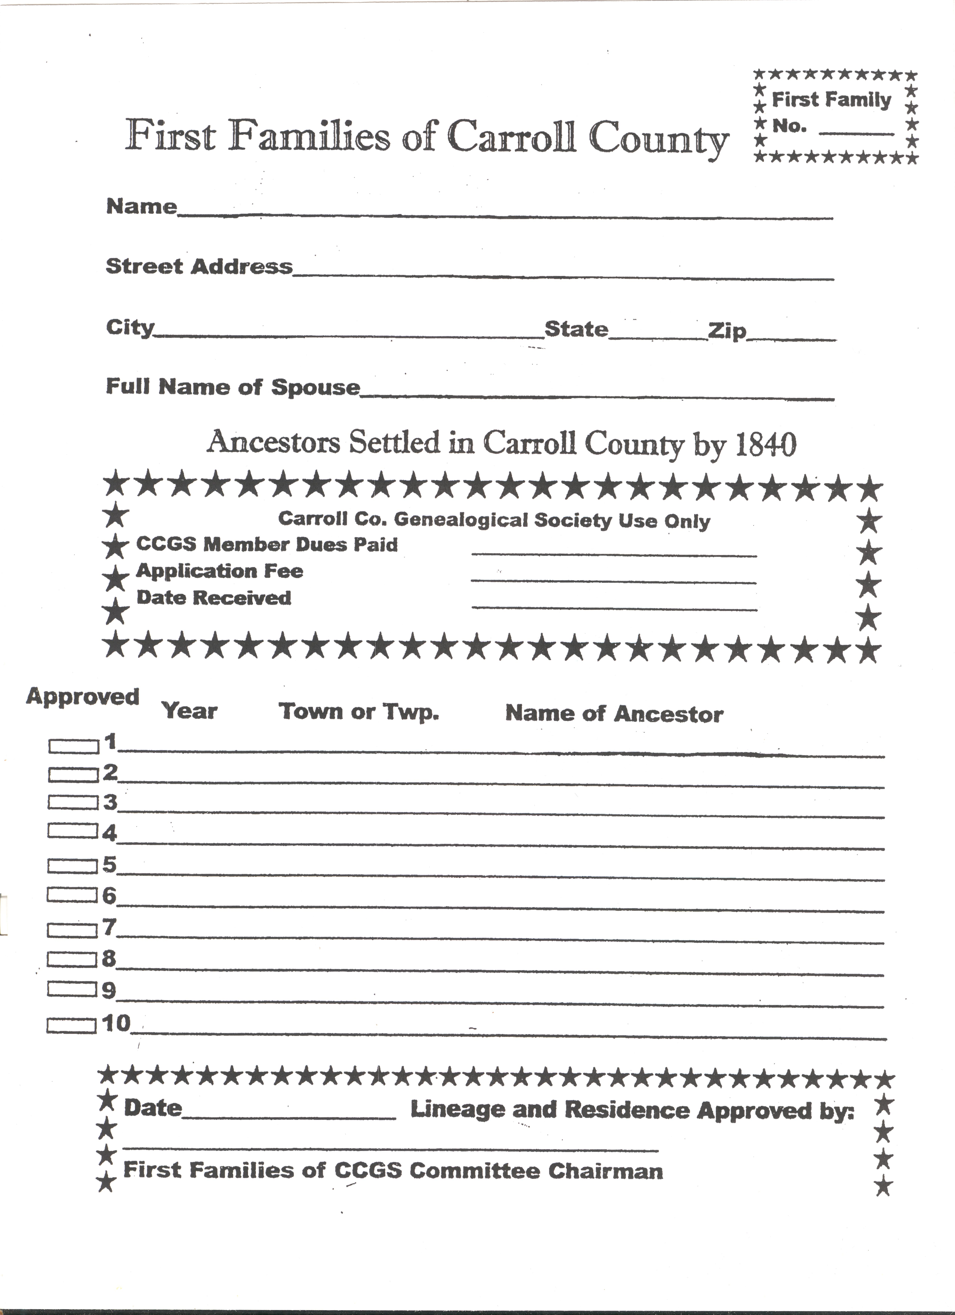

FIRST FAMILIES OF CARROLL COUNTY
Any member of the Carroll county Genealogical Society who is a direct descendant of an individual who settled in Carroll County, Ohio by Dec. 31, 1840, may become a member of THE FIRST FAMILIES OF CARROLL COUNTY, OHIO upon the acceptance of an application submitted with proof of such descent and residency and the payment of an application fee of $12.00 The application must be approved by THE FIRST FAMILIES OF CARROLL COUNTY COMMITTEE
RULES OF EVIDENCE
The rules of evidence applying to membership in FIRST FAMILIES OF CARROLL.CQUNTV OHIO follow, and are the standards by which all FIRST FAMILIES OF CARROLL COUNTY OHIO proof is judged. There are no exceptions.
The nature and extent of the evidence submitted as proof in all applications shall be sufficient to prove that the applicant is directly descended from prior ancestor(s) and sufficient to differentiate between any o persons of the same name residing in the same area at the same time.
BASIC RULES
1. Primary or collateral evidence from vital statistics, courthouse or other government records, church and school records, etc., is usually considered to be beyond doubt and an excellent proof.
2. Secondary evidence such as 1840 census records, newspaper clippings, old letter, B or other family records, contemporary to the facts reported is considered almost as authentic.
3. Circumstantial evidence or “hearsay” is not considered proof unless backed up by primary or secondary evidence.
4. Oral written or published family traditions are not accepted as proof.
5. Printed or manuscript genealogies, or genealogical records charts, family reunion records and similar material are not considered proof. Unsupported information from an amateur or a professional genealogist is not acceptable, including such cords printed in any genealogical, historical or similar publication.

6. Lineage papers, accepted or unaccepted, from other patriotic or hereditary societies by
themselves are not considered proof. The document copies, which were used to prove the lineage, MIGHT be considered proof is they follow the rules established by THE CARROLL COUNTY FIRST FAMILIES committee.

7. If a document merely implies a fact, this is not considered proof. An example is the expression “heirs at law” used in some states. This indicates different things in different states, but in no case found is it used as an indication or proof of direct descent. The statement could mean nieces nephews, cousins, adopted children, or even parents.

8. Copies of old letters, family records, etc., can be accepted as proof only for facts the writer of the record or letter would logically know of-his own, contemporary knowledge. They cannot be accepted as proof for facts the writer could only have obtained by hearsay from older generations, or other sources.

9. Land transactions (deeds, warrants, grants, tax records, etc.) can only be accepted as evidence of settlement in Carroll County if the record actually states that the individual was “of Carroll County.”

10 Female ancestors must be proved as individuals by their maiden name.

11. A direct line from applicant to pioneer ancestor must be proved at every step. Collateral descent is not applicable.

12. All proof documents must state their source. Bible records must include a photocopy of the title page with publication date and current owner’s name and address.

13: Typed, handwritten or printed copies of original documents must be certified as a “TRUE COPY” by a courthouse or other official, or a librarian, etc. An applicant or member of his or her family cannot certify a document as a “TRUE COPY.” Photocopies of original documents are acceptable as copied if there are no changes on the original.

14. Married female applicants must include a copy of their marriage record of prove their change of name.

15. Photographs of tombstones are acceptable for proof of birth and death dates and for relationships actually stated on the stone. Published compilations of tombstone readings are acceptable if no additional information has been written in that is not on the stones themselves.

16. Additional applicants for more than one pioneer ancestor do not require duplicate information of proof.

1. ____________________________ was born _______________________________
At_____________________________________________________________________
City County State

Proven by Document No: ____ (Stark Co. birth) ________________________________________________________

2. I am the child of ____________________________________________________
Born on ____________ at _____________________________________________________
City County State Dec No. _____
Died on____________ at _________________________________________________
City County State Dec No. _____
And_____________________________________________ , his wife
Born on ____________at _____________________________________________________
City County State Dec No. _____
Died on ____________at ________________________________________________
City County State Dec No. _____
Married on ________ at _______________________________________________,,.
City County State Dec No. _____
3. The said ____________________________was the________________________
son or daughter
Of_____________________________________________________________________
Born on_______________________ at ______________________________________
City County State Dec No. _____
Died on ____________at ________________________________________________
City County State Dec No. _____
And_____________________________________________ , his wife

Married on ________ at _______________________________________________,,.
City County State Dec No. _____
4. The said ____________________________was the_______________________
son or daughter
Of_____________________________________________________________________
Born on_______________________ at ______________________________________
City County State Dec No. _____
Died on ____________at ________________________________________________
City County State Dec No. _____
And_____________________________________________ , his wife

Married on ________ at _______________________________________________,,.
City County State Dec No. _____

5. ____________________________ was born _______________________________
At_____________________________________________________________________
City County State
Proven by Document No: ____ (Stark Co. birth) ________________________________________________________

2. I am the child of ____________________________________________________
Born on ____________ at _____________________________________________________
City County State Dec No. _____
Died on____________ at _________________________________________________
City County State Dec No. _____
And_____________________________________________ , his wife
Born on ____________at _____________________________________________________
City County State Dec No. _____
Died on ____________at ________________________________________________
City County State Dec No. _____
Married on ________ at _______________________________________________,,.
City County State Dec No. _____
6. The said ____________________________was the_______________________
son or daughter
Of_____________________________________________________________________
Born on_______________________ at ______________________________________
City County State Dec No. _____
Died on ____________at ________________________________________________
City County State Dec No. _____
And_____________________________________________ , his wife

Married on ________ at ________________________________________________
City County State Dec No. ____
7. The said ____________________________was the_______________________
son or daughter
Of_____________________________________________________________________
Born on_______________________ at ______________________________________
City County State Dec No. _____
Died on ____________at ________________________________________________
City County State Dec No. _____
And_____________________________________________ , his wife

Married on ________ at _______________________________________________,,.
City County State Dec No. _____

This application, information, and all supporting documents and data become the property of the Carroll County Genealogical Society.

Documentation proving settlement in Carroll County by 1840.

Authorities as to descent
Example; Doc. 1. Stark Co. Birth; Doc. 2. Carroll Co. Marriage
Generation
1______________________________________________________________________
_______________________________________________________________________
2______________________________________________________________________
_______________________________________________________________________
3______________________________________________________________________
_______________________________________________________________________
4______________________________________________________________________
_______________________________________________________________________
5_____________________________________________________________________
_______________________________________________________________________
6______________________________________________________________________
_______________________________________________________________________
7______________________________________________________________________
_______________________________________________________________________

Date____________________________

I do hereby swear that the statements set forth in this application, are true to the best of my knowledge and belief.

Signature of Applicant______________________________________________

