Paul McCormick’s Home Site History
Tuesday, November 24, 2026 (Added details on the cabin construction from Paul’s descendants)

After his marriage to Mary Spear in Helena on February 23, 1879, they traveled to Bozeman, staying for three weeks, attending many parties. Upon reaching Columbus, they spent the night at Major Pease’s home. Departing there in the morning, they arrived at Young’s Point in time for dinner, and then spent the night there. Huntley was the next stop and they stayed at the McGirl & Hoskins’ store. From there they made it to Junction City, where Paul had one of his trading posts. They slept in the rear of the store, on a dirt floor.

Junction City

They remained in the trading post for a very short time while inventory was being completed. After looking around for a home, they purchased property from Jacob Ellis in 1879 [Lots 15-16, Block 85] under a Warranty Deed. The deed was eventually recorded in Paul’s name on 6 July 1885. The property was located in the flatland on the north side of the Yellowstone River, upstream of the Big Horn River, where Fort Custer was located. They had originally planned to spend a few days at the Junction City store before continuing on to Miles City, where they expected to establish their residence. A local stage arrived that first night and the driver announced that the Indians had attacked the area near Pompeys Pillar, killing Ed Stearns and another man. It was feared that they would attack other settlers in the area, so Paul and Mary quickly joined the stage to Miles City. They stayed there until late in the fall (1879), after which they returned to Junction City.

During the first winter (1879) they lived in two-rooms in back of Paul’s store. In the spring Paul built their first home, a spacious log cabin, on the land bought from Jacob Ellis. This home was built in two parts, with the major addition added a few years later. Their children, Edith, Paul Jr., and Guy were born in this home.

The original section had a long hallway leading to the dining room and parlor at one end, with a large bedroom & kitchen at the other end. In 1887, Paul added another section onto the cabin, forming an “ell shape” to the structure.

Paul was a notable figure, and while he resided in Junction City, his whereabouts were duly noted in the weekly newspapers. Virtually every issue contained some tidbit about him.

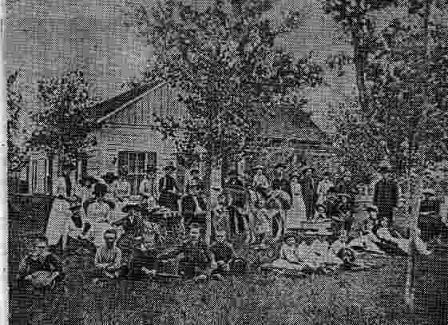
They lived in this home for over 12 years [1880-1893]. Pictured in 1887 are friends and members of the McCormick family. The house is constructed in two sections joined together to make one larger home. The log cabin section is directly behind the guests, and on the left side of the picture. After the railroad line was built, Junction ceased to exist, and by 1894, only one residence, a log cabin remained. All the others were torn down and relocated.

To preserve the family history, many available photographs were donated to the Parmly Billings Library.

Billings

Paul established several business partnerships in Billings by 1891, but did not relocate his family until two years later.

In 1893 Paul moved his family to Billings, and immediately thereafter started to acquire all of the property located in Block 6, of the town site. Several of the lots were held in jointly titled names, and were Quit Claimed to him; along with several Warrant Deeds from previous owners Additionally he acquired large acreages for ranching activities. Various sources verbally describe (from memory) his home and the cabins he built or acquired. Verification of the constructions is noted where applicable. Letters written to T. C. Power, in Washington DC, indicate that he resided in junction through 1892. Early in 1893, his correspondence address changed from Junction City to Billings.

Victorian Home at 404 North 31st Street (Corner of 4th Avenue North and 31st St)

Before Paul and his family arrived in Billings, he acquired Lots 1 through 6, in Block 6 of the Original Town site [1/4 – city block], from Alfred Myers on 1 January 1893. This was where he built his large Victorian home, using the existing residence as a starting point. It sat on lots 1, 2 & 3.

Alfred Myers purchased lots 1-3 from T. M. Morgan. Alfred, in 1885, built a home on the premises, consisting of wood framing and brick veneer that covered a log cabin. Alfred then acquired the adjacent vacant lots 4-6 from M. L. Knowlton and his wife Annette on May 27, 1886 for $125.00.

Six years later, Paul purchased from the Yellowstone County Commissioners, lots 7-8 & 13-14 on October 4, 1893. He eventually owned all of Block 6. The cabin was constructed on lots 7 & 8, and was parallel to the alley. That makes the cabin reconstruction immediately after the land purchase.

In 1953 the major residence was demolished to make way for the Socony-Vacuum Oil Company’s building. The front portion of the residence was moved to 2114 North 11th Street; the rear (northern portion) was destroyed. After Socony-Vacuum purchased the property much of home furnishings were acquired by the Buffalo Bill Museum in Cody. The home was a landmark of elegance, and contained a hanging staircase designed by R. R. Rowe, a Boston cabinetmaker who moved to Billings in 1892. The home contained seven fireplaces; and a Packet Steamer originally shipped most of the furnishings to their first home in Junction City.
In 1908 he sold his business holdings to the Yegen Brothers and Hughes & Yates. After retirement he ran an elk & buffalo ranch along the edge of the north rims in Billings, until the herd got too large to manage, and had to either be destroyed or abandoned. Many of the elk were donated to the Elk’s Organization. He owned a business building on North 29th Street, and a block of residences on North 31st Street.

Log Cabin became the “Peter Yegen Yellowstone County Museum.”

Conflicting dates and construction stories from friends and acquaintances abound about this cabin. All are essential factual, although some clarity as to the timeframes is needed to establish the actual origination date as being the end 1879. The cabin was completed in spring of 1880. Paul and his family lived in Junction City until 1893.

Mar 26, 1891 – “Paul returned home [Junction City] from somewhere. He is gone so much it is hard to find out where he goes or when he comes home”.

Nov 22, 1891 – Paul’s letter to TC Power written in Junction City.

Dec 4, 1892 – Paul’s letter to TC Power written in Junction City.

From additional letters Paul was in Junction City on Feb 16, 1893 and again on March 2, 1893. On March 7th he was in Crow Agency. On March 16th he was established in Billings, as evident from his crossing out the Junction City name on his company’s stationery, and inserting Billings. He traveled to St Paul for medical treatment, and on June 1st wrote Powers that he would depart there the following Monday, and to write him at home, now Billings. On March 17, 1895 he signed up for voter registration in Billings. On March 31, 1894 he established his wholesale business in Billings.

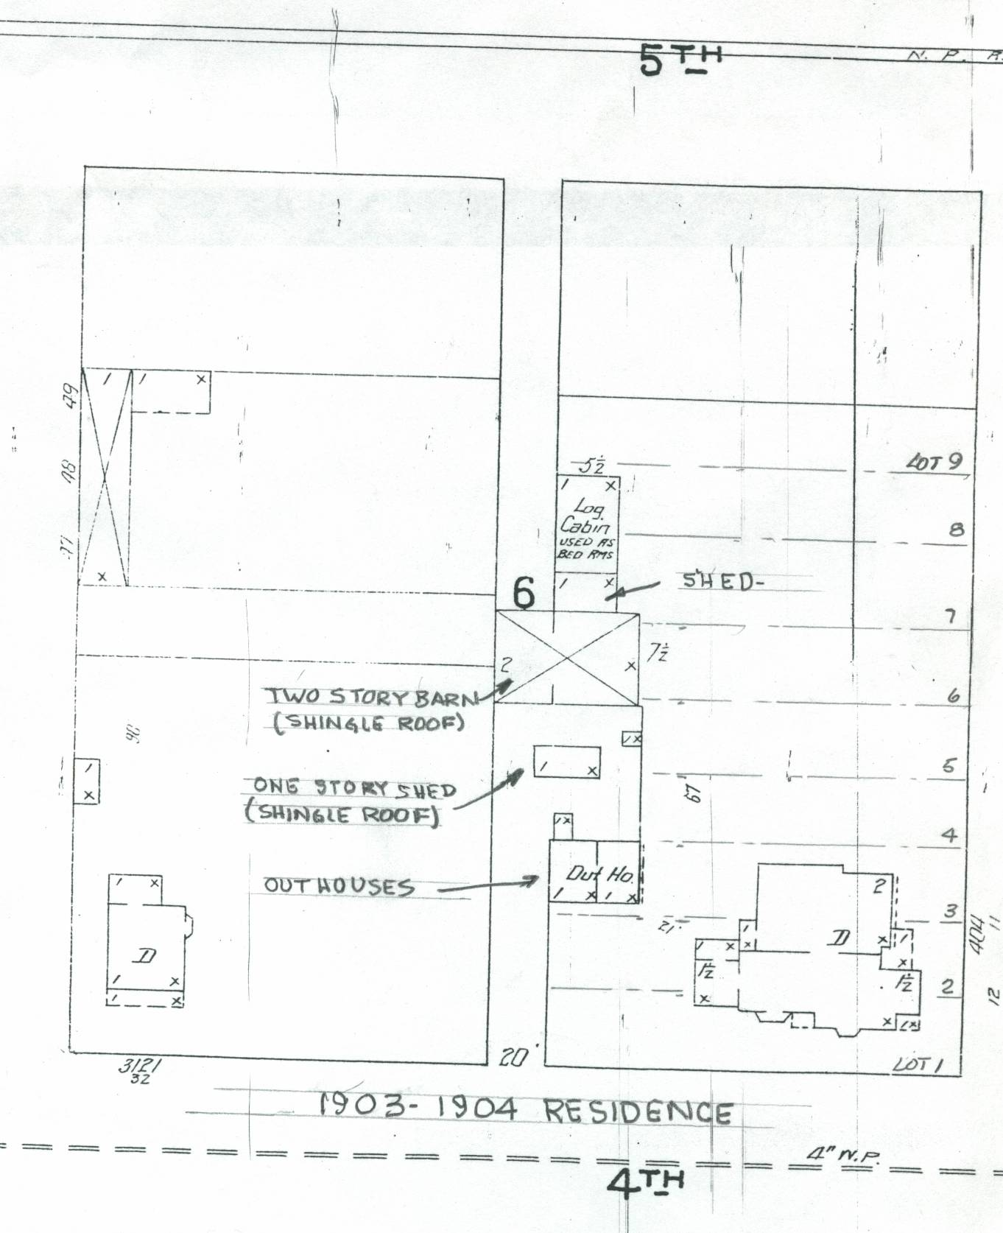
Paul had a 22x34 foot long log cabin constructed after his arrival in Billings in 1893 on the northern end of his residential property (lots 7-8, Block 6) adjacent to his home, and near the alley. He intended it to be used as a business and social meeting place. Paul reportedly transferred ownership to his son; Paul Jr in 1918. [Court records could not be located to verify the transfer, but must have occurred after his death and transfer of property to his wife.] The cabin was also reportedly sold to Mrs. Nellie Elliott, who in turn sold it to the YWCA. This does not agree with the property settlement between the estate and the Socony-Vacuum oil company; who took title to the cabin along with other buildings and property in 1953. In either case, the cabin remained on the site during the transfer or ownership, and then had to be moved prior to demolition of the entire site.
The logs for the cabin were definitely not cut specifically for this building, but are clearly “used.” They were randomly assembled without regard to the original intended design. Beveled edges of many of the horizontal wall-logs, used initially for window and doorframes, are butted up without a need for an opening. This presents an “odd appearance to the structure.” The walls were also raised about eight inches by insertion of additional small log filling pieces between the top two rows of logs. These beveled edges appear to conform to the halls and rooms originally built by Paul for the Junction City home. This ceiling “barrier” was probably used as the tacking board for the hard ceiling installed into the cabin when it was in Junction, and used as their first home. When re-installed in Billings, the ceiling wasn’t used in the cabin, but appears it could have been used in the main residence as evident from some photographs. No specific details about this as being absolutely factual have been located. The re-assembled cabin had also re-arranged the window settings to better suit a single-room.
The cabin constructed in 1879-1880 by Paul in Junction City was “spacious.” It also had separated interior areas for a dining room, parlor and a bedroom. An opening was cut in 1887 to mate with an addition he added. When he departed Junction, there was no record of him having transferred ownership of the property to another person. Since the town was in its “death throws”, he, along with other residents apparently abandoned the land, and by 1894 (six months later) only one structure remained. As the town disappeared, all traces of its existence ceased. There was no reason to leave the logs and other building materials behind, so Paul had to have moved these materials to Billings, and reassembled them into the one-room log cabin entity on his Billings lots. This would have left many of the original logs with beveled edges as used in the original construction that contained interior walls, to be butted against others along the exterior walls in the new cabin. In the early 2000’s descendants of Paul’s convened in Billings; and they reported that Paul most certainly transported the logs to Billings for reconstruction. (Gazette Issue)
In 1952-1953 Socony-Vacuum Oil Co. chose the McCormick block for their new office site, which included the detached log cabin. On April 13, 1953, Peter Yegen and Paul McCormick, Jr., asked the oil company for the cabin stating they planned to use it for a museum. Oil company manager, W. W. Clawson gladly gave them the cabin, with the stipulation it be moved within 30 days. Numerous city officials assisted in clearing the land and property holding details that concerned the transfer. One of the problems was that no one wanted the cabin to be placed on or near their land. Eastern Montana College [MSU-Billings] had land available, but the details needed to gain permission could not be accomplished within the allotted time. Land on the Pioneer Park site’s north boundary was originally designated to be a museum site, but 17 citizens living near by objected stating: “the cabin would hurt the Park as it was originally intended.” Dick & Marjorie Logan came up with idea to place it on the rims. This idea was approved and Fred Zeier moved the building, sod roof and all before the deadline had expired. Prior to the move, Arthur Archibald disassembled the interior fireplace and each stone numbered for resetting after the cabin was placed into its final position. The carved stone mantle was inadvertently hauled to the dump by a workman, but was recovered. It was stated by townspeople “the reason the museum is on the rims by Bill Hart’s monument is he was the only one who didn’t object to it.” The Northern Pacific switch engine, identical to the ones used in Billings [but not one of the engines actually placed in service in Billings], was donated to the museum & the Eastern Montana Pioneers Association. The Hi-Ball Contractors moved the engine “Old 1031” to its final resting spot after it arrived in Billings under its own power. Edward B. Stanton from St. Paul presented the engine to the town on May 25, 1957. In the fall of 1959 the Yellowstone Historical Society purchased the Walters’ collection of Indian artifacts, the finest and oldest collection in the county, and displayed them in the museum. The cabin was called the Peter Yegen Yellowstone County Museum, but changed in 2010 to Yellowstone County Museum.
The cabin was originally situated approximately N-S on the family lot in Junction. The entrance door (leading into the hallway), was on the east. The numbers in the circles denote views of pictures taken in 1880 by Mrs. McCormick showing the interior arrangement. Note that the curtains are draped over the floor.
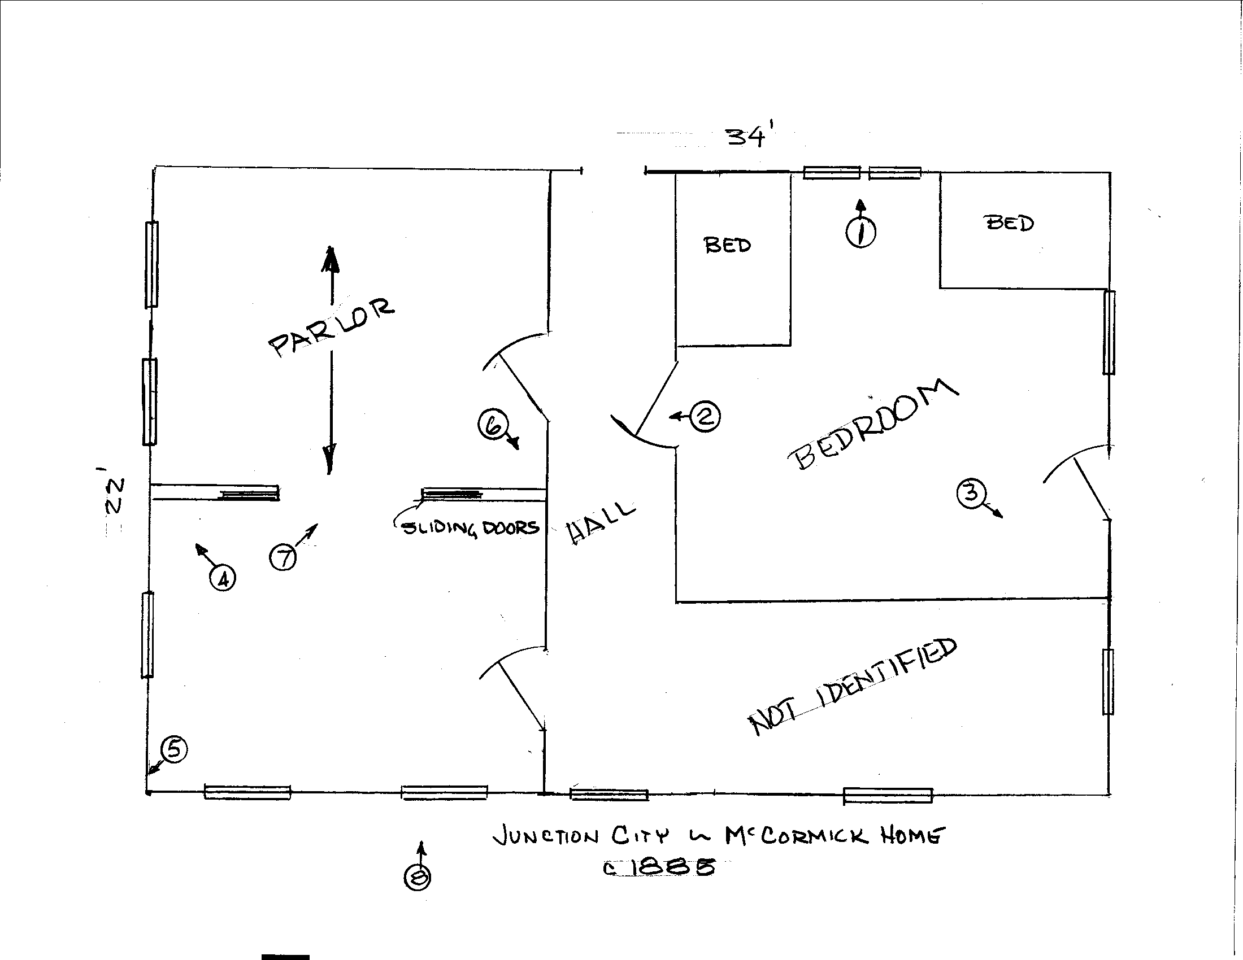
Sketch re-constructed from photos dating to 1885.

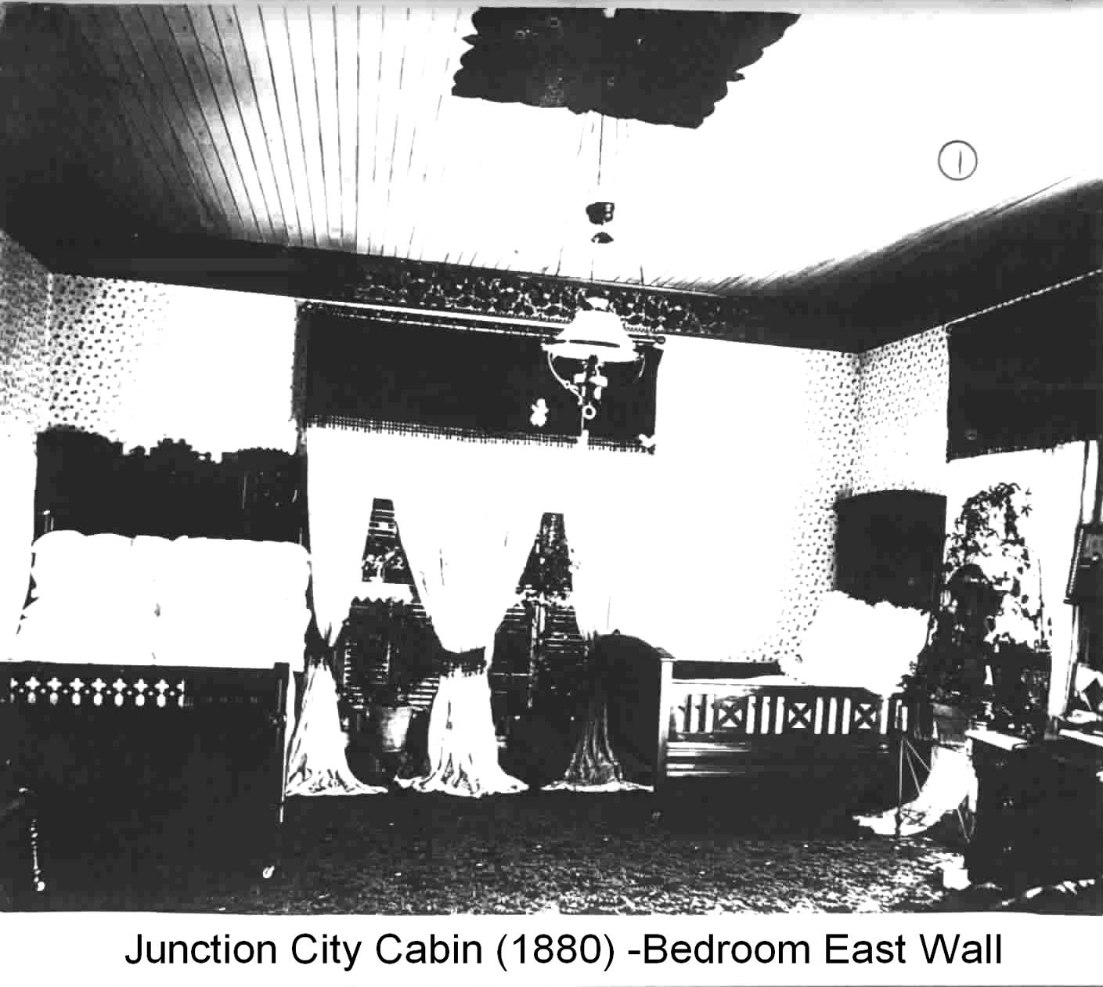 | 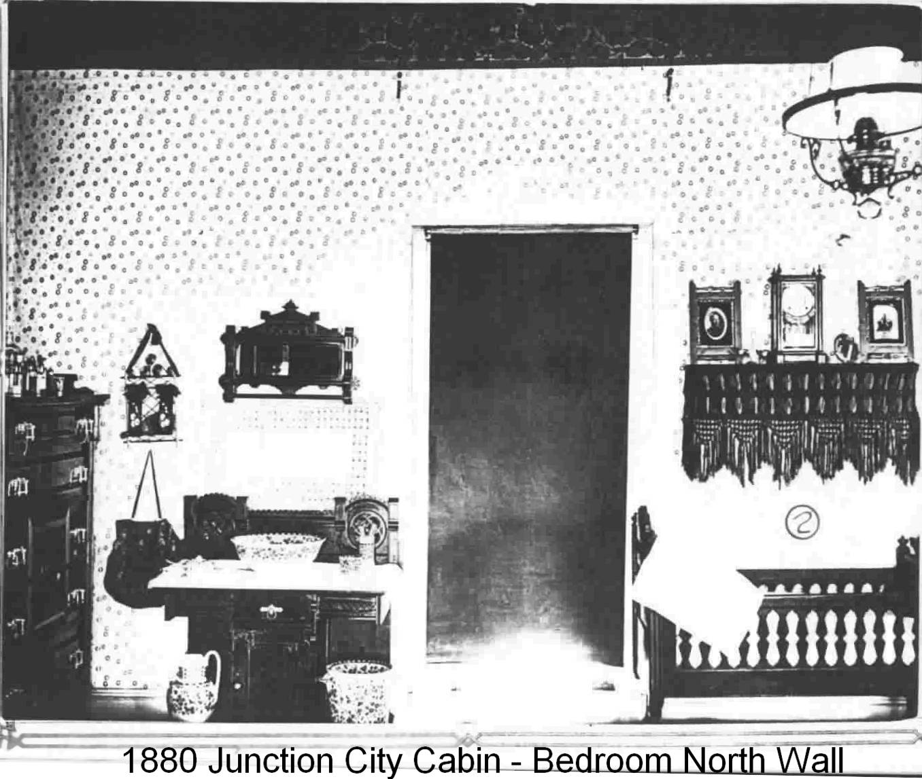
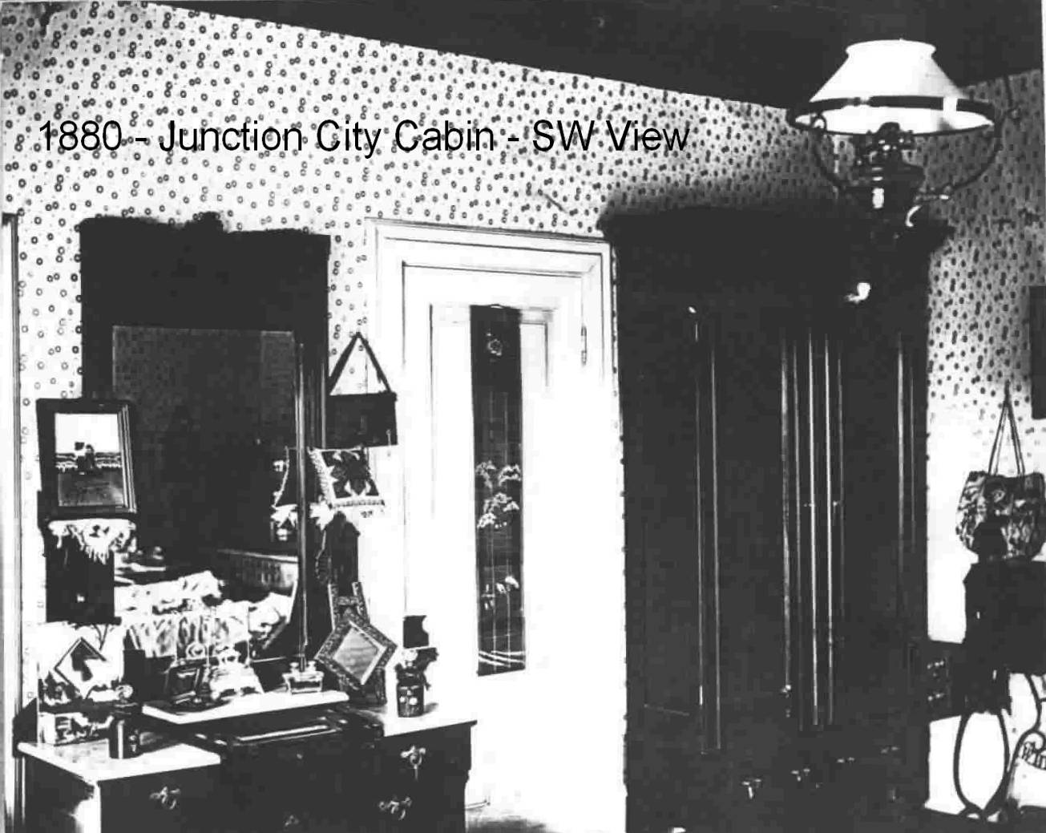 | 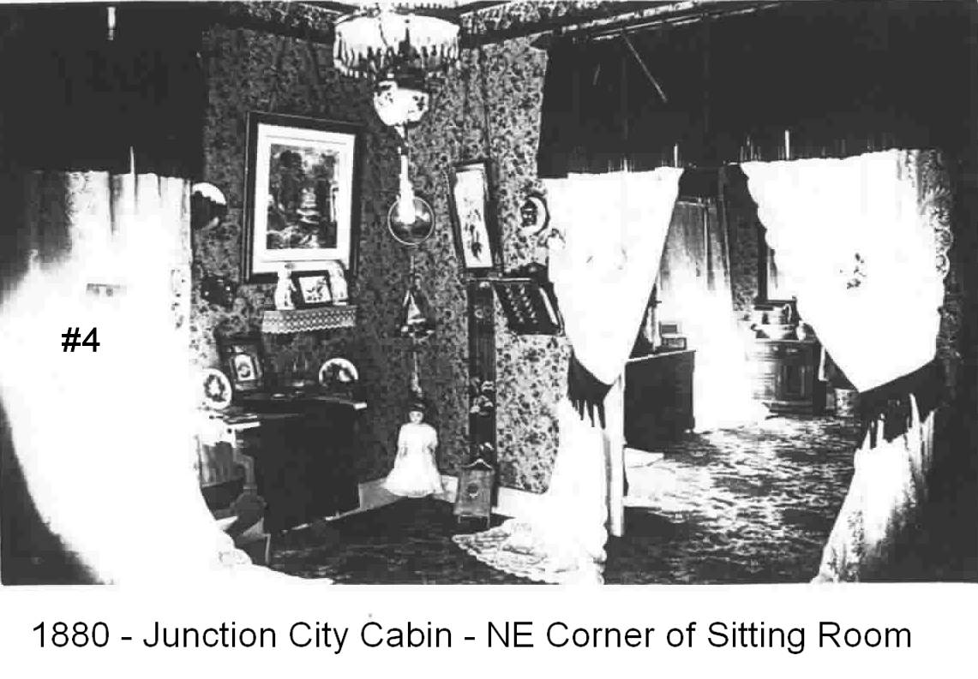
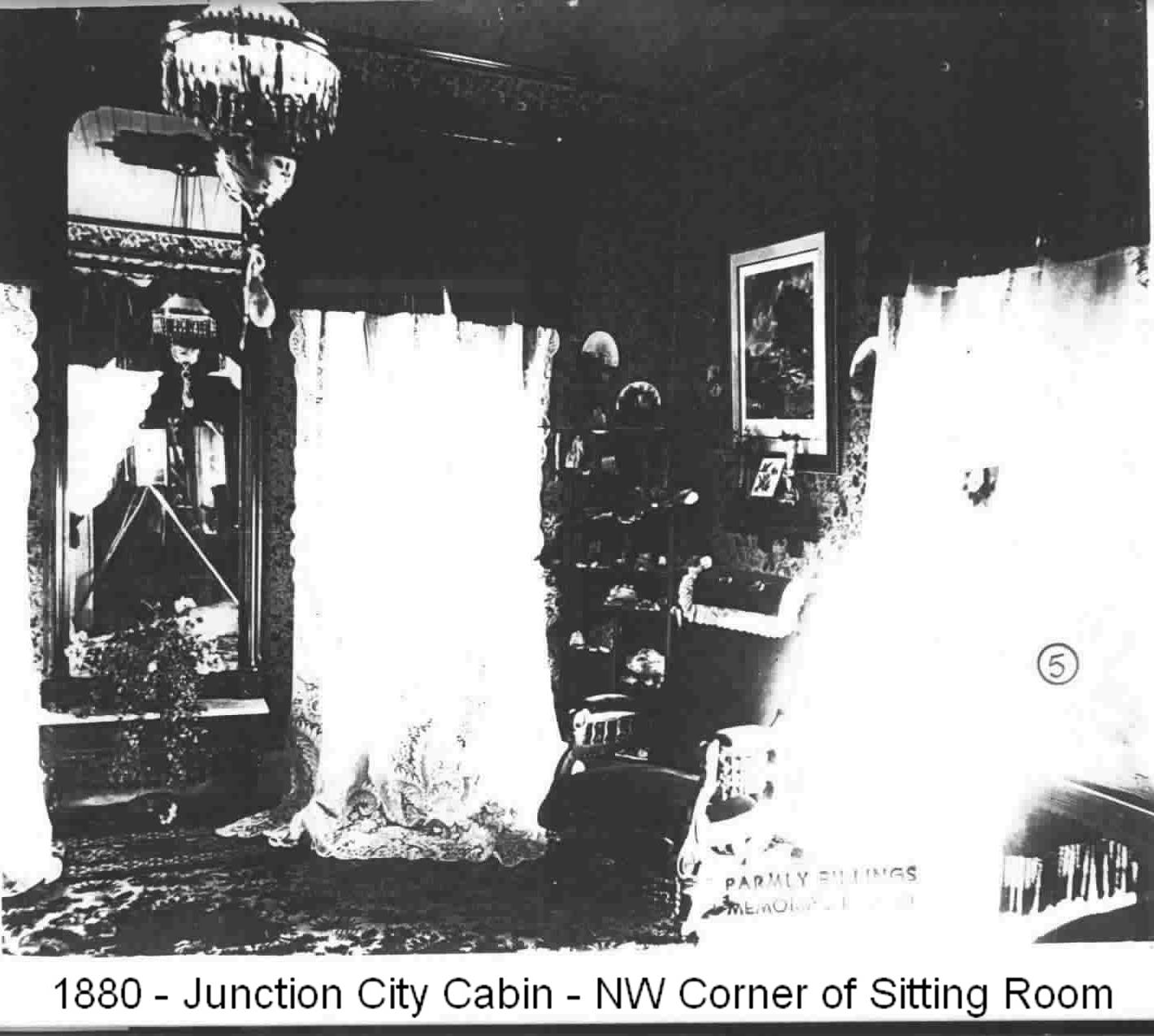 | 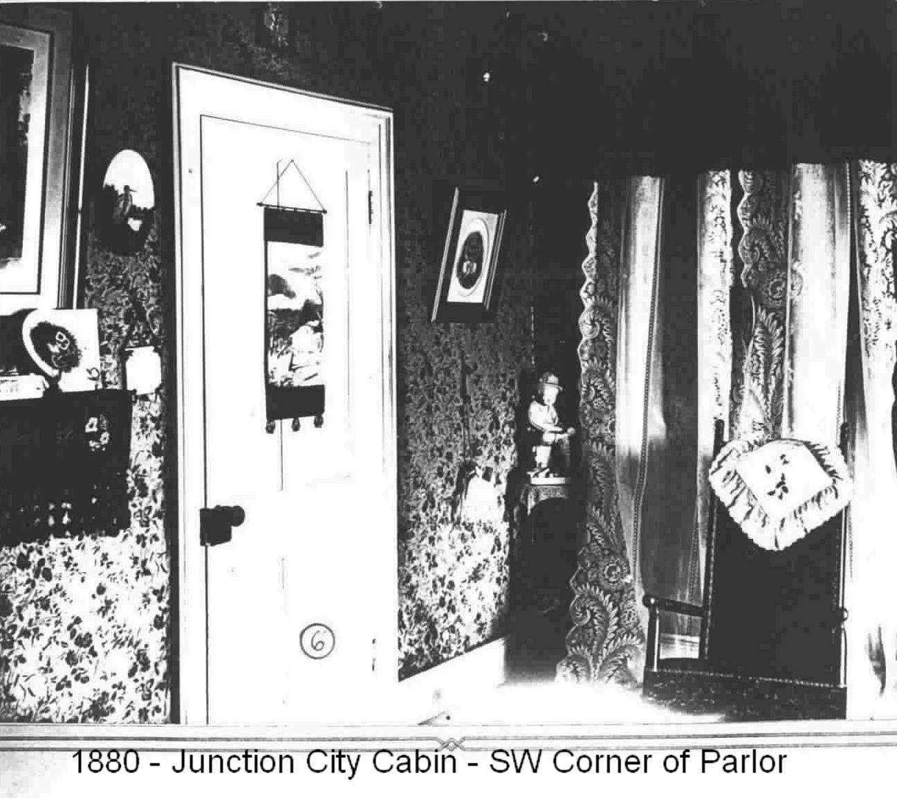
The not identified area was probably their kitchen. Apparently, the kitchen stove provided the only heat. The stovepipe exit was evidently made directly through the cabin walls, as the overall view of the cabin shows no exterior vent.

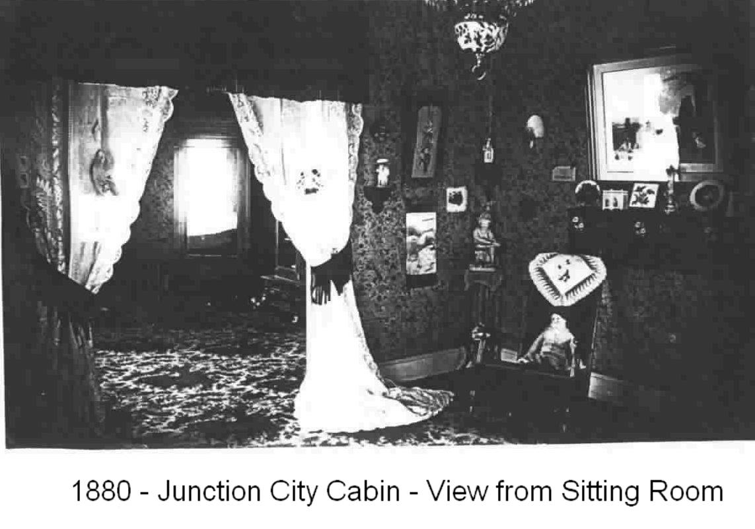

Parmly Billings Library, Biography File, May 11, 1947.
See Deed Book A-559; Yellowstone County.
Mary McCormick, Bio of Paul, Parmly Billings Library Vertical Files; undated publication.
Gazette, 27 January 1921. “Uncle Paul McCormick Grand Old Man of State Dies After Long Illness”
Ibid Note 1. Lists the people in the picture.
Scrap book article, Billings Gazette “When Life Was Both Pleasant and Raw” , unsigned or dated.
TC Power Collection. Montana Historical Society, Helena. Boxes 1, 4 and 28 correspondence files (1891-1893)
Filed 12 April 1893, Book F page 527, Yellowstone County.
Filed 11 Sep 1885 (Book E page 7), Yellowstone County. Quit Claimed. (Morgan’s name has been copied in some articles as “Conrad.” [eg., John H. Conrad] Morgan’s original ownership has not been located.
Old McCormick Home at Billings Becomes Victim of City’s Growth, Kathryn Wright, Spring 1954, Montana Magazine of History.
Recorded in Book F, Page 23, Originally filed in Hennepin, MN, the re-recorded in Yellowstone County.
Recorded in Book E. page 137. Yellowstone County. Quit Claimed.
Junction City News (copied into the Billings Gazette)
Box 1, folder 28, TC Power Collection.
Box 27, Folder 23, 1893 Powers records.
Sanborn Map of Billings, 1904 (McCormick Block)
Charles Zimmerman reported that the cabin was built in 1904 to have a place for young people to meet. Along the Zimmerman Trail, 1977. This has to be a memory error.
Resided at 416 N 31st Street. Operated the Elliott Seed Company.
“Old McCormick Home at Billings Becomes Victim of City’s Growth”, Kathryn Wright, Spring 1954, Montana Magazine of History.
Donated to Parmly Billings Library, and held in the locked storage vault in the Montana Room.

