The Cox Family History

? Where Did I Come From ?

Country—England County—Somerset Parish—Meare Village—Catcott, Edington, Burtle District—Bridgewater

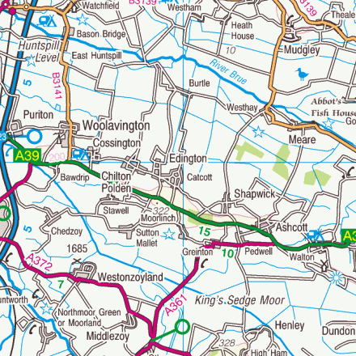

William Cox Family

William Cox Somerset, England

Married

Betty (--?--) Cox

Their Sons

Charles Knight Cox July 18, 1790 Catcott Burtle, Bridgewater, Somerset, England (Died Jan-Feb-Mar 1879)

John Cox June 22, 1778 Somerset, England

William Cox April 01, 1792 Somerset, England

John Cox November 03, 1793 Somerset, England

George Cox Somerset, England (Died June 18, 1780)

Their Daughters

Hannah Cox February 15, 1789 Somerset, England

Ann Cox May 13, 1781 Somerset, England

Mary Cox October 30, 1796 Somerset, England

Meare Parish Baptism Records

Charles Knight Cox Family

Charles Knight Cox July 18, 1790 Catcott Burtle, Bridgewater, Somerset, England (Died Jan-Feb-Mar 1879)

Married 08/04/1817

Maria (Harper) Cox 1796 Catcott Burtle, Bridgewater, Somerset, England (Died 1851-1861)

Their Sons

George Cox May 25, 1820 Catcott Burtle, Bridgewater, Somerset, England (Died February 5, 1898)

Henry Cox Dec. 1831 Catcott Burtle, Bridgewater, Somerset, England (Died January 16, 1907)

Charles Cox October 06, 1822 Catcott Burtle, Bridgewater, Somerset, England (Died August 29, 1876)

Edmund Cox 1836 Catcott Burtle, Bridgewater, Somerset, England

Thomas Cox 1834 Catcott Burtle, Bridgewater, Somerset, England (Died 1900-1910)

Their Daughters

Hester Cox March 11, 1827 Catcott Burtle, Bridgewater, Somerset, England

Maria Cox July 05, 1829 Catcott Burtle, Bridgewater, Somerset, England

Jane Cox January 31, 1821 Catcott Burtle, Bridgewater, Somerset, England

Martha Cox June 1839 Catcott Burtle, Bridgewater, Somerset, England

Alice Cox January 09, 1825 Catcott Burtle, Bridgewater, Somerset, England

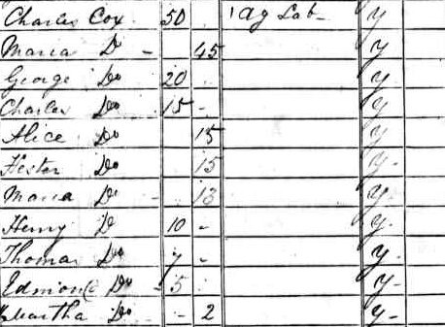
1841 Census England
Thomas Cox Family

Thomas Cox 1834 Catcott Burtle, Bridgewater, Somerset, England (Died 1900-1910)

Married 1st Wife

Hannah (Harper) Cox 1840 Meare, Bridgewater, Somerset, England

Their Sons

Ernest Cox 1870 Catcott Burtle, Bridgewater, Somerset, England

Fred Cox 1868 Catcott Burtle, Bridgewater, Somerset, England

William Cox 1871 Catcott Burtle, Bridgewater, Somerset, England

Their Daughters

Kate Cox 1869 Catcott Burtle, Bridgewater, Somerset, England

Clara A. Cox 1873 Catcott Burtle, Bridgewater, Somerset, England

Hannah Cox 1874 Catcott Burtle, Bridgewater, Somerset, England

Married 2nd Wife

Mary Ann (--?--) Cox 1833 Mark, Bridgewater, Somerset, England

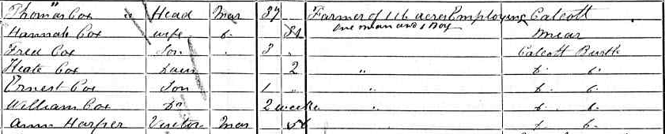
1871 Census England

Edmund Cox Family

Edmund Cox 1837 Catcott Burtle, Bridgewater, Somerset, England

Married

Jane (Norris) Cox 1838 Catcott Burtle, Bridgewater, Somerset, England

Their Daughters

Ada Cox June 1868 Edington, Bridgewater, Somerset, England

Minnie Cox June 1872 Edington, Bridgewater, Somerset, England (Died 1910)

Florence Cox 1861 Catcott Burtle, Somerset, England

Alice Cox 1866 Catcott Burtle, Bridgewater, Somerset, England

Their Sons

Ralph Charles Cox September 1877 Edington, Bridgewater, Somerset, England

Alexander Cox June 1876 Edington, Bridgewater, Somerset, England

Arthur Edmund Cox July-Aug-Sept 1869 Edington, Bridgewater, Somerset, England

Ernest G. Cox 1883 Catcott Burtle, Bridgewater, Somerset, England

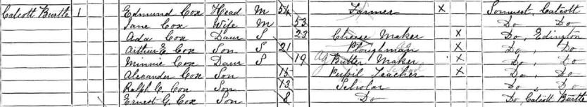
1891 Census England

Charles Cox Family

Charles Cox October 06, 1822 Catcott Burtle, Bridgewater, Somerset, England (Died August 29, 1876)

Married 1st Wife

Elizabeth (--?--) Cox 1825 Catcott Burtle, Bridgewater, Somerset, England

Their Daughter

Anna Cox December 1859 Catcott Burtle, Bridgewater, Somerset, England

Married 2nd Wife

Betsy (--?--) Cox 1825 Edington, Somerset, England (Died June 20, 1888)

Their Son

Hubert Cox 1864 Edington, Somerset, England

Their Daughters

Ellen Cox 1861 Edington, Somerset, England

Frances Cox 1866 Edington, Somerset, England

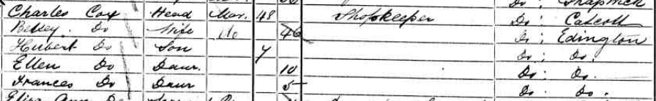
1871 Census England

Henry Cox Family

Came to US in 1854

Henry Cox Dec. 1831 Catcott Burtle, Bridgewater, Somerset, England (Died January 16, 1907)

Married

Margaret A. (Riley or Reilly) Cox 1834 Ireland (Died January 8, 1900)

Their Sons

Charles Edwin Cox January 1, 1865 Connerville, Fayette, Indiana (Died January 3, 1949)

Benjamin Franklin Cox 1859 Ohio (Died May 28, 1937)

Harry Cox 1863 Connerville, Fayette, Indiana (Died December 29, 1908)

George C. Cox Dec. 1873 Washington, Buchanan, Missouri

Their Daughters

Catharine Cox 1868 Connerville, Fayette, Indiana

Emma C. (Cox) Woods July 20, 1854 Ohio (Died June 2, 1947)

Hattie B. (Cox) Kennedy June 02, 1863 Connerville, Fayette, Indiana (Died September 10, 1943)

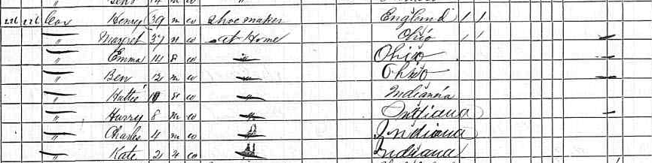
1870 Census USA Missouri

George Cox Family

George Cox May 25, 1820 Catcott Burtle, Bridgewater, Somerset, England (Died February 5, 1898)

Married 09/21/1851

Ellenor (Norris) Cox May 30, 1831 Catcott Burtle, Bridgewater, Somerset, England (Died May 13, 1915)

Their Sons

David Cox March 15, 1852 Catcott Burtle, Bridgewater, Somerset, England

Oliver George Cox Aug. 12, 1859 Catcott Burtle, Bridgewater, Somerset, England (Died May 27, 1933)

Their Daughters

Evelina Hester (Cox) Miles December 1860 Catcott Burtle, Bridgewater, Somerset, England

Lousia Jane Cox June 1854 Catcott Burtle, Bridgewater, Somerset, England

Maria G. Cox June 1857 Catcott Burtle, Bridgewater, Somerset, England

Anna Eliza (Cox) Wall June 1867 Catcott Burtle, Bridgewater, Somerset, England (Died March 1894)

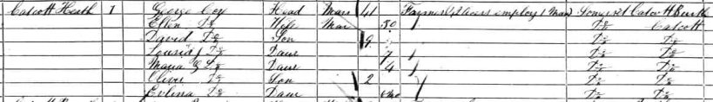
1861 Census England

David Cox Family

Came to US in 1874

David Cox March 15, 1852 Catcott Burtle, Bridgewater, Somerset, England (Died 1930-1940)

Married 1878

Agnes (Cartwright) Cox 1859 England (Died 1900)

Their Daughters

Daisy Jane (Cox) Thomas November 21, 1878 Rock Creek, Clackamas, Oregon, USA (Died November 9, 1971)

Annie Bell Cox 1880 Rock Creek, Clackamas, Oregon, USA

Lillie May Cox Rock Creek, Clackamas, Oregon, USA

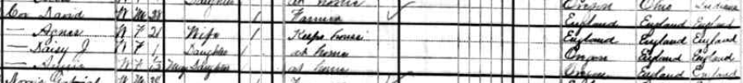
1880 Census USA Oregon

Oliver George Cox Family

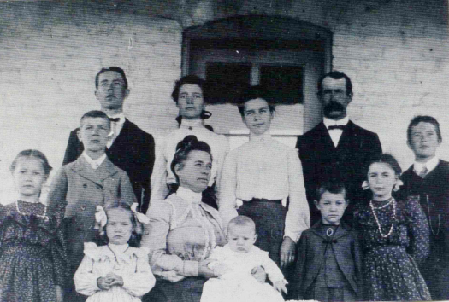

Richard, Olive, Louise, Oliver
Robert, William
Alice, Isabel, Anna
Florence, Harold, Charles

1904

Oliver George Cox Aug. 12, 1859 Catcott Burtle, Bridgewater, Somerset, England (Died May 27, 1933)

Married 06/05/1884

Isabel (Chambers) Cox September 11, 1866 Scarborough, Yorkshire, England (Died Dec 24, 1920)

Their Sons

Richard George Cox May 29, 1885 Portland, Oregon (Died February 7, 1920)

William John Cox April 20, 1890 Watertown, Codington, South Dakota (Died August 3, 1986)

Robert Oliver Cox March 22, 1892 Watertown, Codington, South Dakota (Died May 1965)

Charles Edward Cox February 8, 1898 Washington, Buchanan, Missouri (Died 1952)

Harold Walter Cox May 23, 1903 Washington, Buchanan, Missouri (Died March 1971)

Their Daughters
Olive Eleanor (Cox) (Ryland) Parks October 14, 1886 Portland, Oregon

Louise Mary (Cox) Waddle September 18, 1888 Watertown, Codington, South Dakota (Died March 27, 1968)

Isabel Anna (Cox) (Dumas) Bullington February 20, 1894 Watertown, Codington, South Dakota

Alice Margaret (Cox) (Baldwin) Russell February 16, 1896 Washington, Buchanan, Missouri (Died 1/2/1973)

Florence Minnie (Cox) Lard February 23, 1900 Washington, Buchanan, Missouri (Died 2002)

Little Stillborn Girl 1902 Washington, Buchanan, Missouri (Died 1902)

Mabel Mayberry (Cox) Long July 31, 1908 Washington, Buchanan, Missouri (Died September 17, 1992)

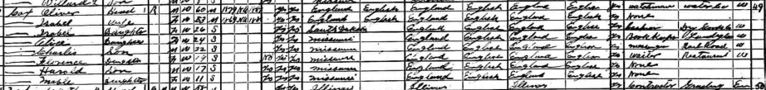
1920 Census USA Missouri

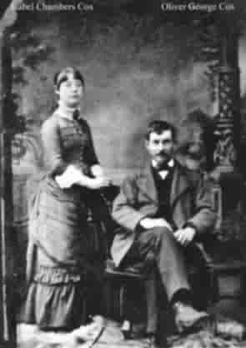

Oliver and Isabel’s Wedding Picture
1884
Charles Edward Cox Family

Charles Edward Cox February 8, 1898 Washington, Buchanan, Missouri (Died 1952)

Married

Mammie (Kuiggie) Cox (Died 1926)

Their Daughter

Alene Florence Cox Feb 28, 1926

Richard George Cox Family

Richard George Cox May 29, 1884 Portland, Oregon (Died February 7, 1920)

Married 10/09/1909

Cyra Etta (Armstrong) Cox 1884 Missouri (Died 1972)

Their Son

Maxwell Milton Cox June 29, 1915 St. Joseph, Buchanan, Missouri (Died 1975)(WWII)

Their Daughters

Dorothy Emerine (Cox) Botsford June 26, 1911 St. Joseph, Buchanan, Missouri

Ruth Isabel (Cox) Taylor February 18, 1913 St. Joseph, Buchanan, Missouri (Died April 24, 2004)

Barbra Helen (Cox) Allen September 18, 1917 St. Joseph, Buchanan, Missouri (Died February 15, 2002)

1920 Census USA Missouri

Maxwell Milton Cox Family

Maxwell Milton Cox June 29, 1915 St. Joseph, Buchanan, Missouri (Died 1975)(WWII)

Married

Mildred Marie (Floria) Cox 1920 (Died 1979)

Their Daughters

Carolyn Sue Cox July 1, 1946

Kathleen Louise Cox June 21, 1954

Their sons

Cox Twins May 28, 1955 (Died May 29th & 30th 1955)

Harold Walter Cox Family

Harold Walter Cox May 23, 1903 Washington, Buchanan, Missouri (Died March 1971)

Married

Hilda Helen (Hopkins) Cox March 25, 1903 Missouri (Died March 25, 1957)

Their Son

Harold Walter Cox Jr. 1929 St. Joseph, Buchanan, Missouri

Their Daughter

Freda Marie (Cox) Reece St. Joseph, Buchanan, Missouri

1930 Census USA Missouri

Robert Oliver Cox Family

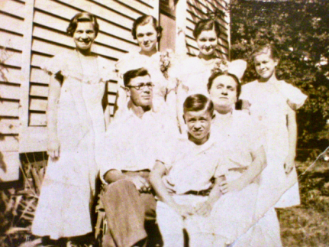

Hazel V., Louise, Roberta, Nannie
Robert, Hazel
Endell

1929-1933

Robert Oliver Cox March 22, 1892 Watertown, Codington, South Dakota (Died May 1965)

Married

Hazel Belle (Loffin) Cox September 8, 1894 St. Joseph, Buchanan, Missouri (Died April 1979)

Their Son

Endell Robert Cox September 3, 1923 St. Joseph, Buchanan, Missouri (Died July 20, 1982)(WWII)

Their Daughters

Roberta Mary (Cox) (Lucas) Thompson 1916 St. Joseph, Buchanan, Missouri

Louise Isabel (Cox) Messbarger 1918 St. Joseph, Buchanan, Missouri

Hazel Virginia (Cox) (Rich) Morrison June 10, 1919 St. Joseph, Buchanan, Missouri (Died August 31, 1955)

Nannie Eva (Cox) Hoecker 1922 St. Joseph, Buchanan, Missouri

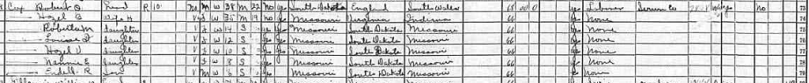
1930 Census USA Missouri

Endell Robert Cox Family

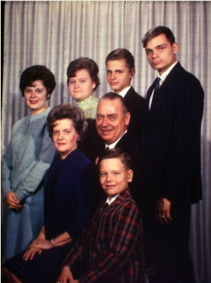

Joyce, Judith, Patrick, Michael
Betty, Endell
Christopher

1966

Endell Robert Cox September 3, 1923 St. Joseph, Buchanan, Missouri (Died July 20, 1982)(WWII)

Married 06/01/1945

Betty Ann (Speelman) Cox October 25, 1925 St. Joseph, Buchanan, Missouri (Died Nov. 28, 1990)

Their Sons

Michael Robert Cox July 24, 1948 St. Joseph, Buchanan, Missouri

Patrick Raymond Cox September 1, 1951 St. Joseph, Buchanan, Missouri

Christopher Louis Cox September 3, 1956 St. Joseph, Buchanan, Missouri

Their Daughters

Joyce Louise Cox March 29, 1946 St. Joseph, Buchanan, Missouri

Judith Marie Cox August 24, 1949 St. Joseph, Buchanan, Missouri

Patrick Raymond Cox Family

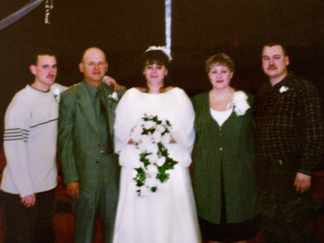

Matthew, Patrick, Jeanie, Linda, Nathaniel

2000

Patrick Raymond Cox September 1, 1951 St. Joseph, Buchanan, Missouri

Married 06/14/1971

Linda G. (Marschel) Cox February 22, 1953 St. Joseph, Buchanan, Missouri

Their Sons

Matthew Wayne Cox April 30, 1976 St. Joseph, Buchanan, Missouri

Nathaniel Lee Cox December 30, 1971 St. Joseph, Buchanan, Missouri

Their Daughter

Jeanie Ann Cox March 31, 1973 St. Joseph, Buchanan, Missouri

Christopher Louis Cox Family

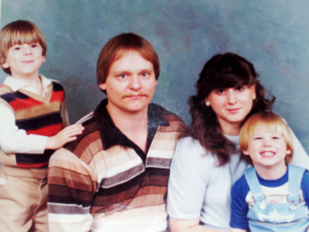

Christopher, Christopher, Connie, Michael

1984-1986

Christopher Louis Cox September 3, 1956 St. Joseph, Buchanan, Missouri

Married 10/07/1978

Connie Dee (Sherard) Cox July 22, 1960 St. Joseph, Buchanan, Missouri

Their Sons

Christopher Louis Michael Cox II September 22, 1979 St. Joseph, Buchanan, Missouri

Michael Endell Cox August 24, 1981 St. Joseph, Buchanan, Missouri

Nathaniel Lee Cox Family

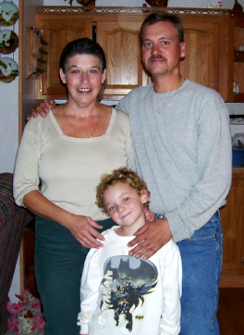

2006

Nathaniel Lee Cox December 30, 1971 St. Joseph, Buchanan, Missouri

Married

Dale Dianna (Baker) Cox July 3, 1960 St. Joseph, Buchanan, Missouri

Their Son Adopted

Camden Nathaniel Cox St. Joseph, Buchanan, Missouri
Matthew Wayne Cox Family

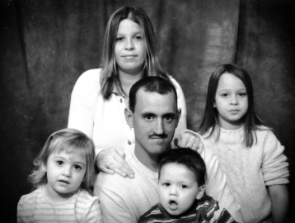

2005

Matthew Wayne Cox April 30, 1976 St. Joseph, Buchanan, Missouri

Married

Tosha Marie (Cannon) Cox March 14, 1982 St. Joseph, Buchanan, Missouri

Their son

Chase Phillip Wayne Cox September 10, 2003 St. Joseph, Buchanan, Missouri

Their Daughters

Haley Nicole Cannon October 25, 1996 St. Joseph, Buchanan, Missouri

Madison Gabrielle Cannon February 2, 2002 St. Joseph, Buchanan, Missouri

Matthew Daughter from another Lady

Erin Marie Dunn September 29, 1995 St. Joseph, Buchanan, Missouri

Michael Endell Cox Family

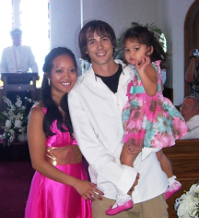

2007

Michael Endell Cox August 24, 1981 St. Joseph, Buchanan, Missouri

Married 07/07/2007

Souphapone Annie Khounnasenh April 2, 1983 Detroit, Wayne, Michigan

Their Daughter

Eyces Proy Cox August 11, 2004 Arlington, Tarrant, Texas

? Where Did I Come From ?

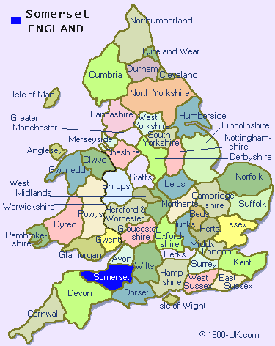

The Cox Family History Book

