2018 November The Tracers Issue 1

Brandon Area
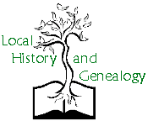

Upcoming Events

December 11
BAGHS Holiday Potluck – 630pm
Bloomingdale Library

January 8
January Meeting – 630pm
Program: Potter’s Field Cemetery, Ray Reed

February 12
February Meeting – 630pm
Program: George Plautz, Genealogist, Retired FBI Investigator

Discounts on DNA Kits
23 & Me
One kit for $69 or two or more kits for $49 each. Savings based on regular price per kit. Offer ends Nov 22.
AncestryDNA
One kit for $69 or two or more kits for $49 each. Savings based on regular price per kit. Offer ends Nov 22.

Family TreeDNA Family Finder
$49 until 11/22

MyHeritageDNA
$49 until 11/22; 2 or more gets FREE Shipping.
Great link for comparison of kits:
https://www.smarterhobby.com
/genealogy/best-dna-test/

Genealogical & Historical Society
P.O. Box 2635
Valrico, FL, 33595-2635
Website: https://baghs.org Georgene Bender, Editor

PRESIDENT’S MESSAGE
After a long absence we are reviving our newsletter thanks to Georgene Bender. Some of our members have joined since we had a newsletter so this will be new to you.

At our November meeting the following officers were elected:
Scott L. Peeler, Jr., President
Georgene Bender, Vice President
Annette Lee, Secretary
Joan Glass, Treasurer

Each of these officers agreed to serving with the exception of Georgene Bender who was newly elected. Our previous Vice President, Stan Heigert, moved to Tennessee. We thank him for his several years of service and miss him very much.

Our Society took part in the 4th Annual Heritage Fair at the John Germany library downtown on 20 October. Liz Matthews and I sat at our information table telling visitors about our wonderful group. The Fair is an annual event which gets better every year. It is totally free and includes workshops of great interest featuring speakers of national renown. I am very glad to say that we had about 15 members from BAGHS who attended the event. This is an event you will not want to miss next year!

We continue to have excellent programs at our monthly meetings. This past meeting was presented by James Preston, a retired Tampa Police Officer, and President of the Florida State Chapter of The Mayflower Society. His presentation was very interesting and gave us a good amount of information about the families who make up the colony.

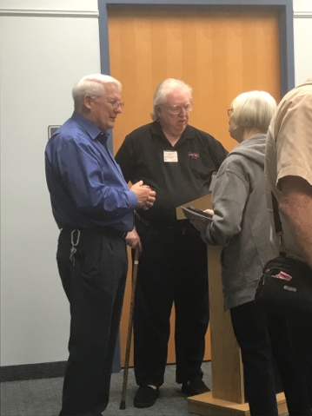

Photo: Speaker, James Preston, Florida Mayflower Society President and President Scott Peeler visit with members after the presentation.

We urge you to think of various programs that would be appropriate for our meetings. Please give us the name and contact information of anyone you may suggest, we have speakers for January, February and possibly March. Of course, in July and December we do not have a program due to our covered dish dinners.

We also need members to sign up for refreshments at our meetings. Two people are needed, one to bring sweet and one to bring salty. Gordon Johnston and Scott Peeler have refreshments for January.

I do want to invite you and your guest to our Christmas covered dish dinner. It is in our usual meeting room at the Bloomingdale Library and begins at 6:30pm.

The genealogy oriented TV programs are beginning soon. Mark your calendars.

Our meetings are held the second Tuesday of every month at the Bloomingdale Library – 1906 East Bloomingdale Avenue, Valrico at 6:30pm. Please plan on attending.

Scott L. Peeler Jr.,
President of B.A.G.H.S

S

Genealogy Series Returns to TV

In the Community

Florida State Fair
Genealogy Exhibit in the Family Living Building on weekends February 9-10; 15-16) See Scott Peeler to schedule time to help. Admission ticket to the Fair will be given.

Membership

Membership Dues are payable on
January 1 of each year and past due
on January 31. Dues can be mailed to
our address or paid at our meetings.
Membership dues are $25 for families,
$15 for individuals or $10 for students.
Membership forms are available on-line at:
http://www.rootsweb.ancestry.com/~flbaghs/
BAGHS_application.pdf

Membership Chair:
Sandra Troublefield

December 3 - WHO DO YOU THINK YOU ARE?
Carried now on TLC, the series has been renewed for an eleventh season that is set to premiere on December 3, 2018 and feature Mandy Moore, Regina King, Josh Duhamel, and Matthew Morrison.
January 8 – FINDING YOUR ROOTS
PBS has announced the premiere date for season five of the genealogy series with Henry Louis Gates, Jr. starting Tuesday, Feb 8, 2019.
Meeting Refreshment Volunteers
December: Everyone bring a dish to pass, Club will provide Ham
January: Gordon Johnston and Scott Peeler
February: Georgene Bender and ?
March:

Ideas for Newsletter

If you have any suggestions for articles or info to share, please send to Georgene at msbobwhite@aol.com. One suggestion is to list our new members monthly. Do share your ideas Thanks for your support to bring this newsletter to our membership.

Here is a current club logo…perhaps we might update this…looking for suggestions.

.