FamilySearch.org - Sherrie Furber - 405-473-7374 - SFurber1@gmail.com May 15 2017
ABSOLUTELY FREE WEBSITE WITH POWERFUL TOOLS AND ALMOST 6 BILLION SEARCHABLE RECORDS
RootsTech 2018 - February 28 through March 3 in Salt Lake City, Utah - www.Rootstech.org
FREE HELP: Call Us 24/7 - Family History Customer Service 1-866-406-1830, Chat Now is LIVE ONLINE HELP
FREE CLASSES ONLINE 24/7 – GET HELP> LEARNING CENTER> LESSONS – PLUS MONTHLY WEBINAR CLASSES
AMAZING FAMILYSEARCH BLOG: https://familysearch.org/blog/en/ SIGN-UP FOR EMAIL NOTICES
FREE SIMPLE START TO FAMILY HISTORY: https://familysearch.org/blog/en/simple-start-family-history-2/ gives you info on how to use FamilySearch.org and projects to get you going with “HOW TO’S”
FREE APPS to help you organize and preserve your family’s history - https://familysearch.org/apps/
THE FAMILY HISTORY GUIDE: http://thefhguide.com/project-1-family-tree.html “How to Navigate FamilySearch” - More info on how to get around in and use FamilySearch.org
How to Search the FamilySearch Site posted on March 6, 2017 By Leslie Albrecht Huber
https://familysearch.org/blog/en/search-familysearch-site/
FamilySearch is bursting at the seams with great records—some of which almost certainly have new information about your family. Their digitized collections from across the world include church, vital, census, land, probate, military, and immigration records as well as many other types of records and histories that can help you uncover your family tree.
How do you unlock the door to find them? All you need is a good search. You can access FamilySearch’s main search screen at https://familysearch.org/search/, or from the bar at the top of the screen, select Search and then Records. From here you can see that there are a few different ways to search. It’s not rocket science—anyone can manage it. But a little extra background knowledge and a few insider tips can streamline your effort and get you on the fast track to success. So that’s exactly what we’ve provided here!
A) The Basic Search: Search by Individual
Looking for a specific person in FamilySearch’s vast collections is the staple of most people’s searching. To search this way, focus on the Search Historical Records box on the left of the main search screen, and follow these simple steps:
Fill in information about your ancestor. It’s easy to assume that the more detailed information you put in about your ancestor, the better. Actually, the opposite is generally true. Here are two secrets to searching success:
- Put in as little information as possible that brings up a reasonable amount of results.
- Experiment with your search criteria. This is important even if you are convinced you have the details exactly right. Errors in the records or indexing might mean your ancestor doesn’t appear exactly as you think he or she should. And sometimes what you know to be the absolute truth about your ancestor turns out to not be so true after all! Try different spellings of names, widen the date ranges, or delete some search criteria. Also, avoid checking the box that says “Match all terms exactly.”
- Push search to get a list of results.
In the example here, we entered information for Charles Mulford as: birth range 1857-1861, born in Illinois. Results look like this (only the top match is shown here): 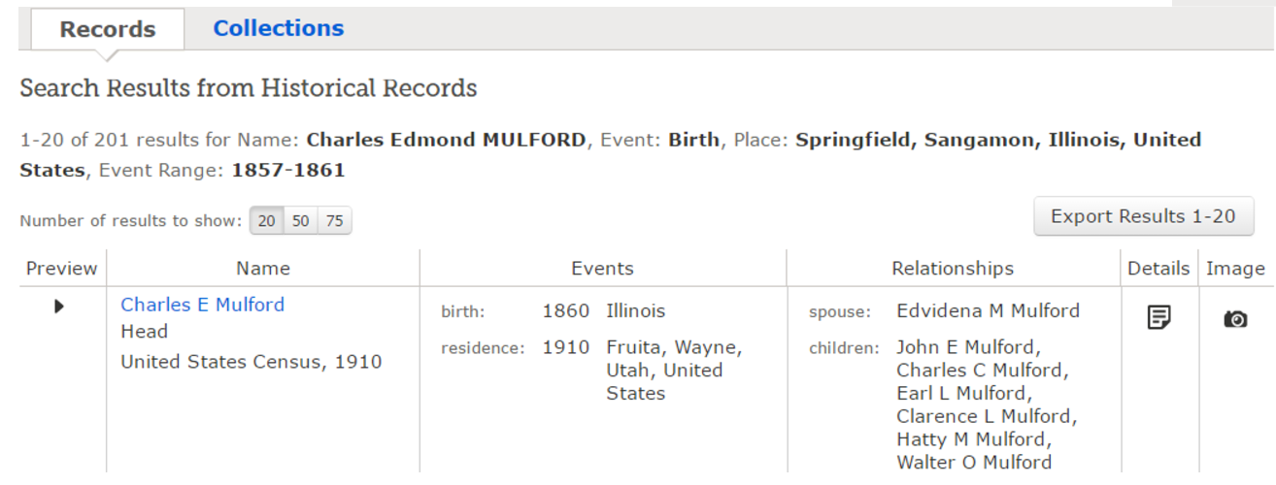
If you think one of the items on the list is a match, select Details or Image. Details will bring up a transcription of the record, while Image will bring up the actual record. Choosing image in this example brings up the 1910 census with Charles and his family. Amazing! Keep in mind that only collections that are indexed are searchable. FamilySearch has many online records that aren’t yet accessible by searching this way.
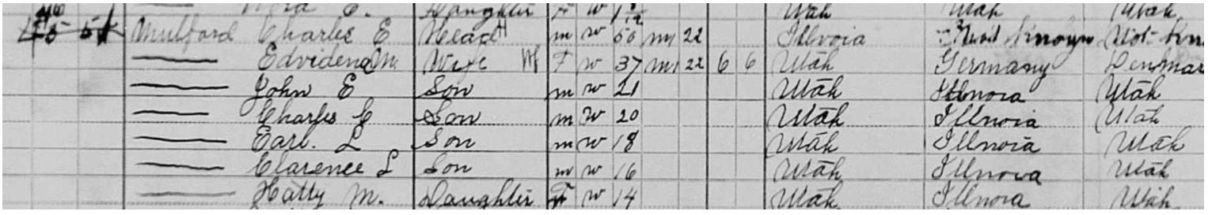
B) Search by Location
Instead of looking to see what records your particular ancestor is included in, you can search to see what records exist for a particular place. Here’s how:
From the main search page, look at the map on the right side. Click on the area of the world you are interested in. From the pop-up box that appears, choose a more exact location, such as a specific US state or country in Europe.
On the next page, type in your ancestor’s name to search indexed records only in that place, and follow the steps in section A to locate your ancestor in those records. OR scroll down to see a list of record groups from that area that aren’t yet searchable but are available for browsing. You may be able to find more information about your ancestor in these browseable records.

C) Search by Collection
The final option on the main search screen is to search by collection. This works best if you already know there is a certain type of record—such as vital records for a particular county or a specific census record—that you would like to search.
To search by collection:
Type in the collection title, or browse their collections.
From the collection page, search for your ancestor following the tips in section A above, if that’s an option, or browse the records if it’s not.
The Sad Case of Unsuccessful Searches
What if you search but don’t have any luck? If your ancestors don’t materialize from these searches, all is not lost! Remember that FamilySearch doesn’t have every record out there, and not all of their records are indexed. As the video below explains, try the location and collection search to find records you might need to browse https://familysearch.org/blog/en/worth-thousand-words-find-imageonly-collections-familysearch/
or even order in on microfilm. Try FamilySearch’s partner sites. And don’t forget to check back often. The holdings available at FamilySearch are constantly growing. So who knows? Maybe the record offering the key to figuring out your family tree is in the record group coming online tomorrow.
Published on May 16, 2016
Did you know searchable genealogy records on FamilySearch account for only about 30% of the data available? Senior Product Manager, Robert Kehrer, shares tips on how to navigate FamilySearch.org to use unindexed images or documents to find more information.
https://youtu.be/kYOrkTrCx-w

