Hamilton County Historical Society Newsletter
SPRING 2010

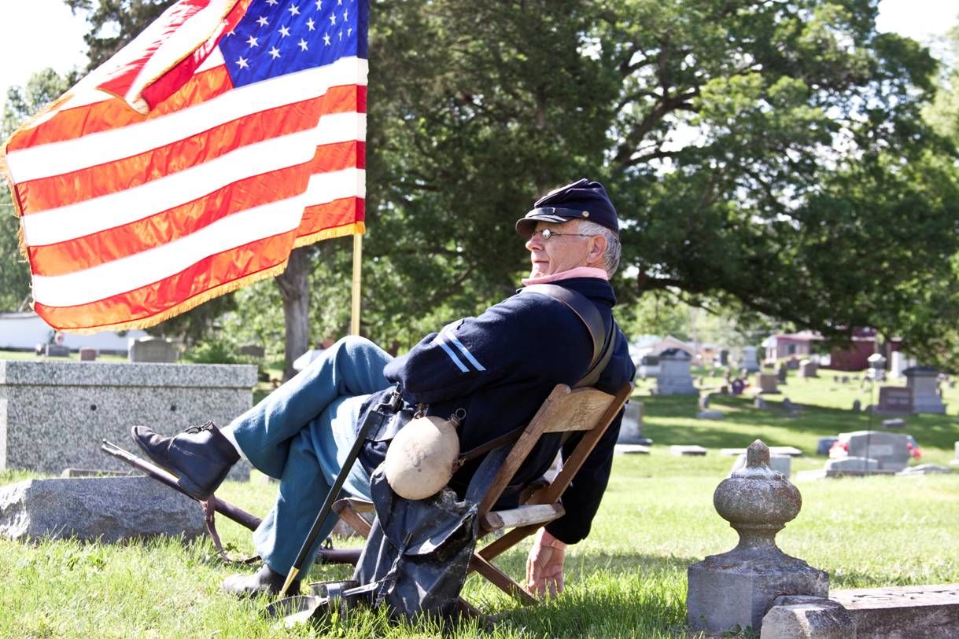
First Cemetery Walk a Success!!
After months of preparation, the Hamilton County Historical Society held its first Cemetery Walk at the I.O.O.F. Cemetery in McLeansboro, Saturday, May 8, 2010. Six Historical Society members dressed in period costumes, stood next to the tombstone of the person they were portraying and gave a presentation of their life as if they were that person. The participating HCHS members were: Marie Sadler (as Almeda Gordon Dycus (1854-1928), Rick Moore (as Peter Hyatt 1821-1903), Ron Nelson (as Charles H. Heard 1814-1891), Donna Mariner (as Elsie Lockwood Blades 1830-1888), Penny VanWinkle (as A. A. Lasater 1842-1924), and Vernia Moore (as Clara Deitz Braden 1863-1935). About 60 people went through the tour, then were treated to refreshments at the tent located in the parking lot of Farris Family Restaurant. “Thank you to the Cemetery Walk Committee for making this event such a success,” Donetta Reed, Cemetery Walk Committee Chair, said. The Committee consisted of: Donetta Reed, Rick Moore, Micki Faruzzi, Donna Mariner, Penny VanWinkle, Vernie Moore, Bob Barker, Joyce Storment, Pat and Marion Russell, Marie Sadler, Ryan Nelson, and Ron Nelson. Photo by Marty Cox, pictured Penny VanWinkle.

“Legacy of Kin” Reprinted!
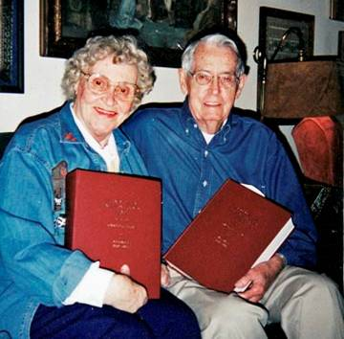
The Historical Society is pleased to announce the reprint of Harold and Christine Felty’s monumental two-volume set, Legacy of Kin, Hamilton County, IL, Relationships, Vital Statistics, Marriages, Abstracted from Obituaries and Notices in Hamilton County Newspapers, Volume 1 1859-1957, Volume II 1958-1992. These books are the result of 14 years of research put in by Harold and Christine. There are over 1000 pages of text in each volume plus every-name indexes. $100/volume plus $5.00 shipping. See back page for order form. Pictured at left are Christine Felty and the late Harold G. Felty.

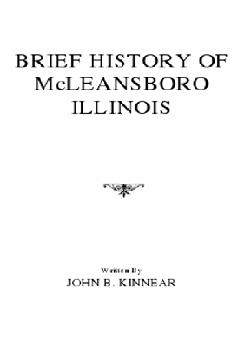
Early McLeansboro History Reprinted
The Historical Society also recently reprinted John B. Kinnear’s Brief History of McLeansboro, Illinois. This text was written in 1883-84. John B. Kinnear was a graduate of Hamilton College, was Superintendent at Carmi Schools, was appointed an auditor in the U.S. Treasury, and was made Secretary of the Civil Service Retirement Association. This book details the town’s formation, schools, churches, societies and more. It is newly indexed. The book is 25 pages, softbound, 5 ½” x 8 ½”. $5.00 plus $3.00 shipping. See back page for order form.

Scholarship Awarded
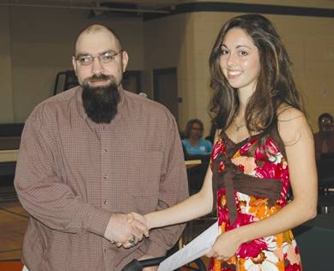
The 2010 Historical Society Scholarship was awarded to Whitney Miller at the Hamilton County High School Honors Program on May 10. Miller is currently attending McKendree University, Lebanon, IL. Pictured at left are Ryan P. Nelson and Whitney Miller. “I'd like to thank the Historical Society for the opportunity to represent Hamilton County as the recipient of the annual Historical Society Scholarship. …The money from this scholarship has helped defray some of the cost of my undergraduate degree. Again thank you very much.” Photo: Paul Lorenz/McLeansboro Times-Leader

Hampden Bank Note Donated to Museum
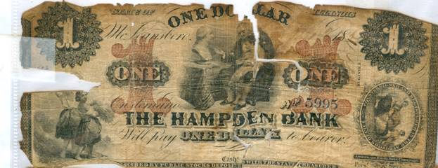
Teresa Patterson recently donated a $1 bank note from an early bank in McLeansboro. The Hampden Bank existed between the years of 1860-1861. She also donated a $5 bank note from The Mechanics Bank of Montreal. These notes are currently on display at the museum.

THANK YOU!!
We would like to express our great appreciation to Donetta Reed and Rick Moore for coordinating the Cemetery Walk and to Micki Faruzzi for assisting in researching the persons portrayed. We would also like to thank the following people who either volunteered, assisted or helped in any way: Mt. Olivet Church, Harry Sanders and Jedd Holloman, Turning Point Church of God, Mike Sumpter, Burt Irvin, Harre Funeral Home & Ambulance, Hamilton County Housing, Bob Barker, Bob Prince, Richard Woods, Food Park, Marty Cox, Times-Leader, Nadine Broyles, Farris Family Restaurant, Brenda Tarlton, Doris Nelson and Marion and Pat Russell. Special thanks to Marie Sadler, Rick Moore, Ron Nelson, Donna Mariner, Penny VanWinkle and Vernia Moore, who portrayed our ancestors so well. Thanks to the committee for all their hard work; Donetta Reed, Rick and Vernia Moore, Joyce Storment, Micki Faruzzi, Ryan Nelson, Penny VanWinkle, Donna Mariner, Marie Sadler and Bob Barker.

* * * * * * * * * * * * * * * * * *

New Officers for 2010
At the October 2009 Annual Meeting, the officers were elected for the year 2010

Ryan Nelson, President David Dykstra, Trustee
Bob Barker Vice President Donetta Reed, Trustee
Clara Farris, Treasurer Brenda Tarleton, Trustee

Doris Nelson, Secretary

* * * * * * * * * * * * * * * * * *

2010 Memberships now being accepted
If you would like to join the Hamilton County Historical Society or renew your membership for 2010, individual memberships are $10 per person. Business memberships are $30 or more per year. Make checks payable to the Hamilton County Historical Society and send to: Doris Nelson, Membership Chair, 409 N. Pearl St., McLeansboro, IL 62859.

* * * * * * * * * * * * * * * * * *

2010 Business Members
The Hamilton County Historical Society would like to thank the following businesses for their continued support:

Auten’s Pizza House Irvin Jewelry
Banterra Bank Little and Associates
Chapman Insurance Max and Dana Hunt
Farris Family Restaurant McDonalds Restaurant
Flannigan Tire Service McLeansboro Space Center
Fox Communications Peoples National Bank
Gholson Funeral Home Rapp Cabinets
Hamilton County Flooring White Oak Resources
Hamilton Memorial Hospital District Wilson’s Computers
Harre Funeral Home and Ambulance York Pharmacy
Hunt’s Hardware and Grocery
Hamilton County Historical Society
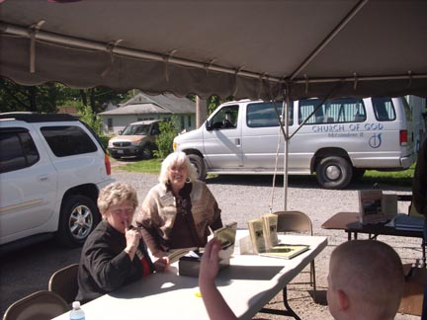
Cemetery Walk
May 8, 2010

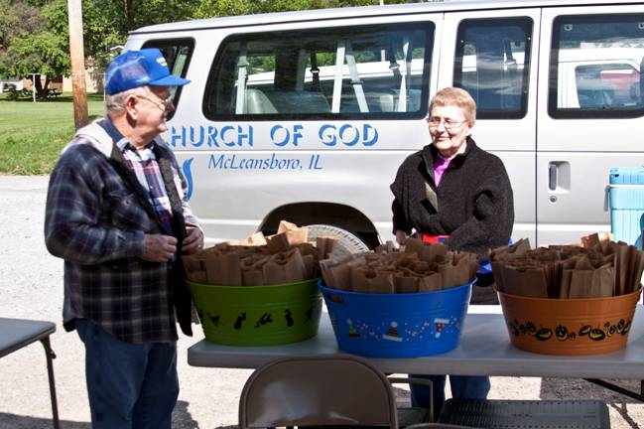
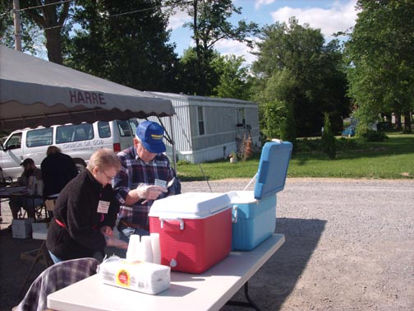
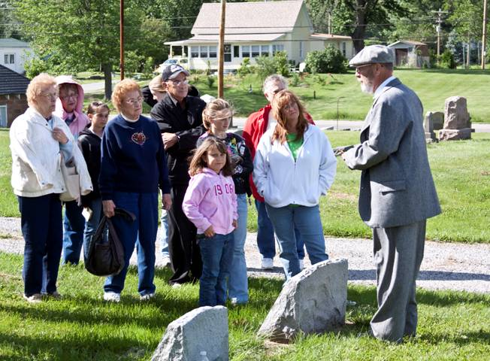
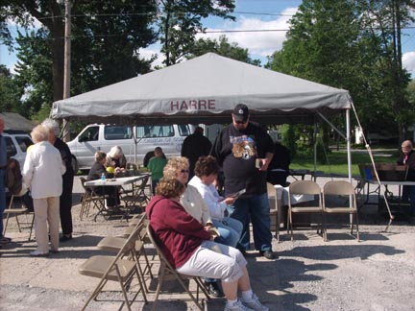
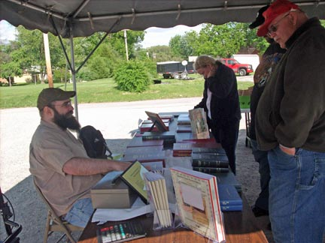
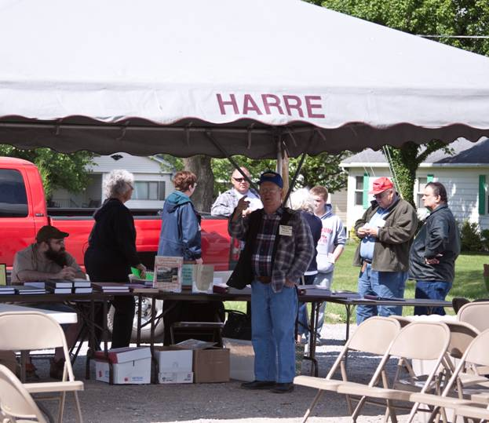
Photos by Marty Cox and Doris Nelson
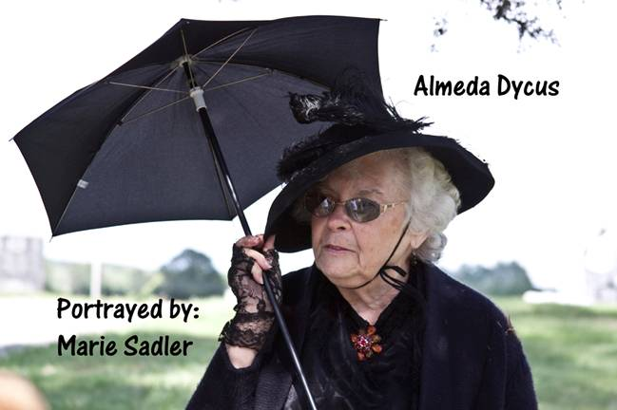
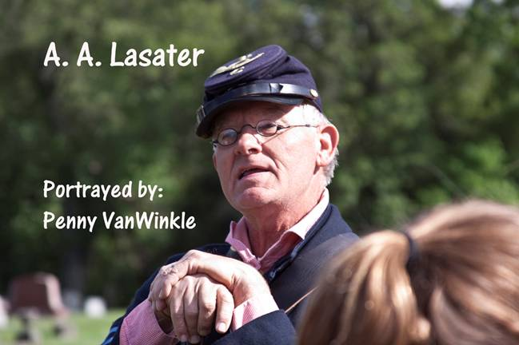

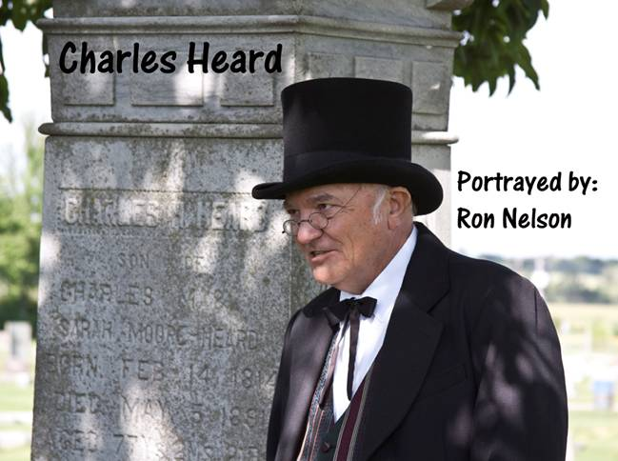
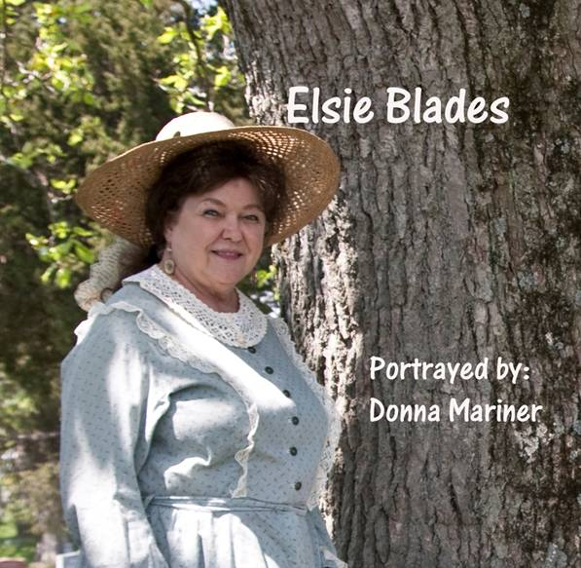
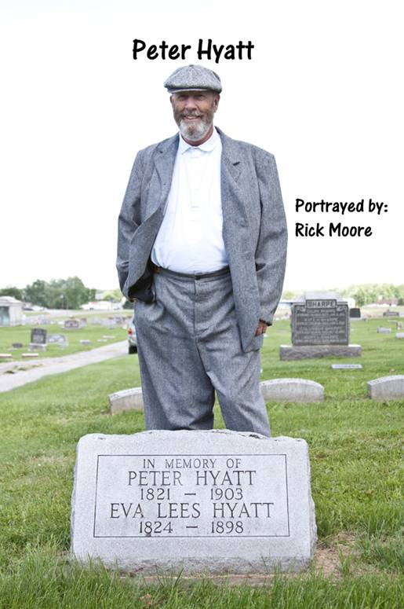
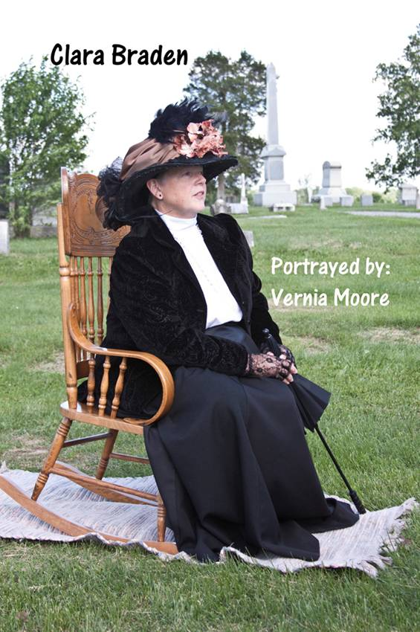
Photos by Marty Cox
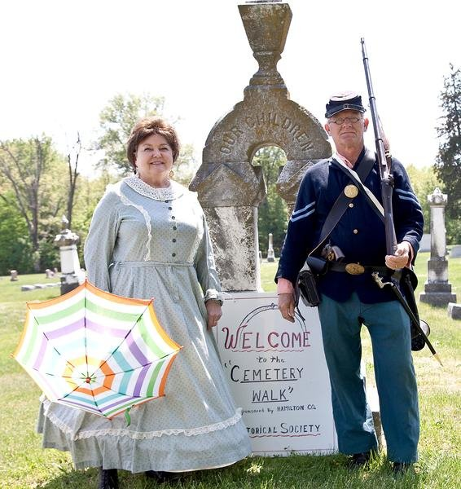
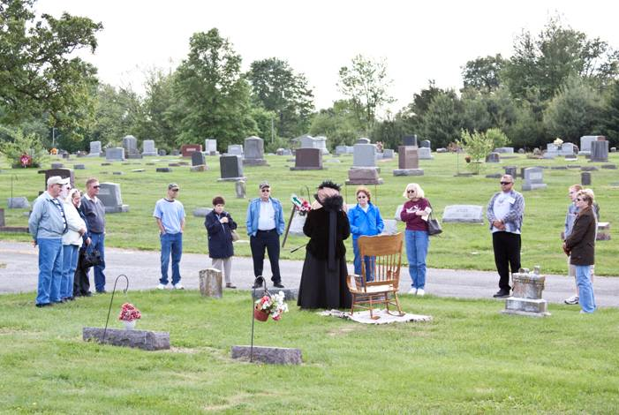

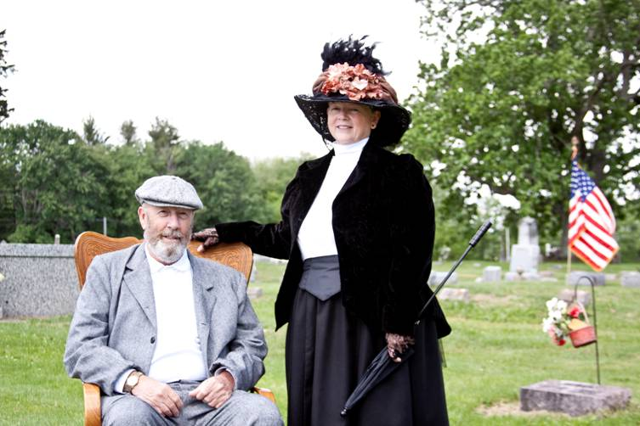
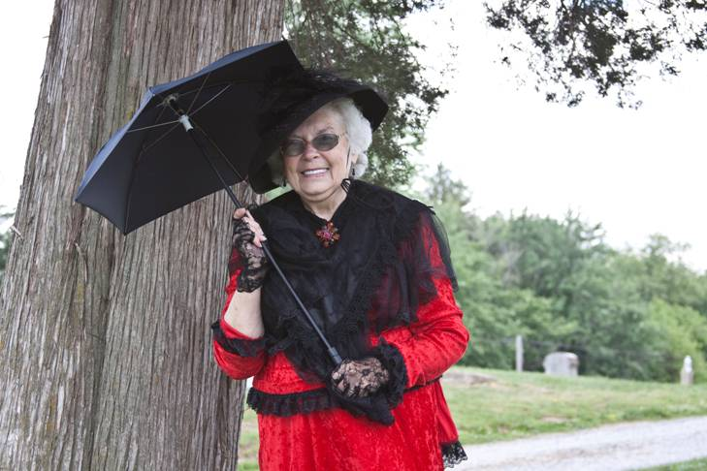
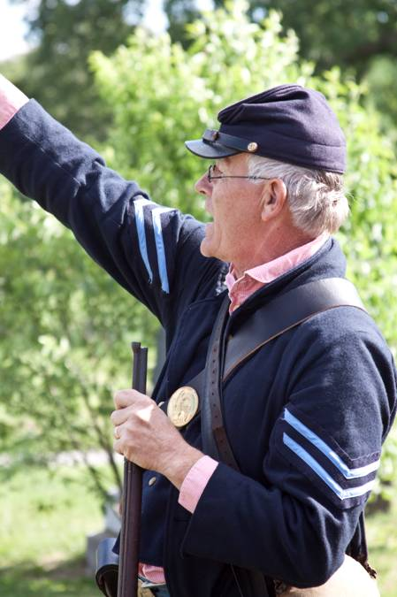
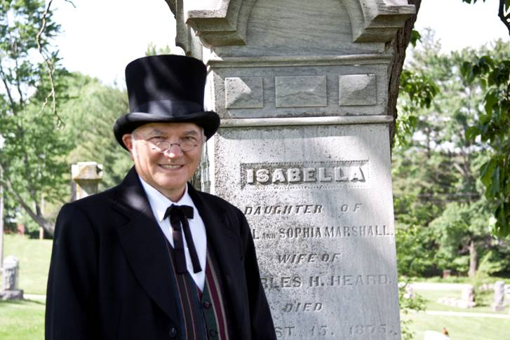
Photos by Marty Cox.
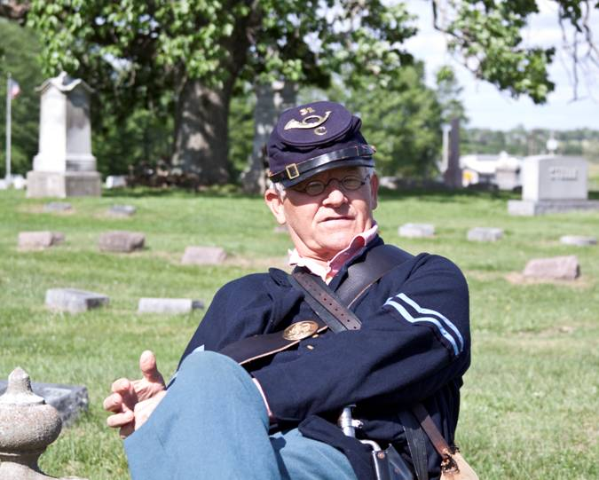
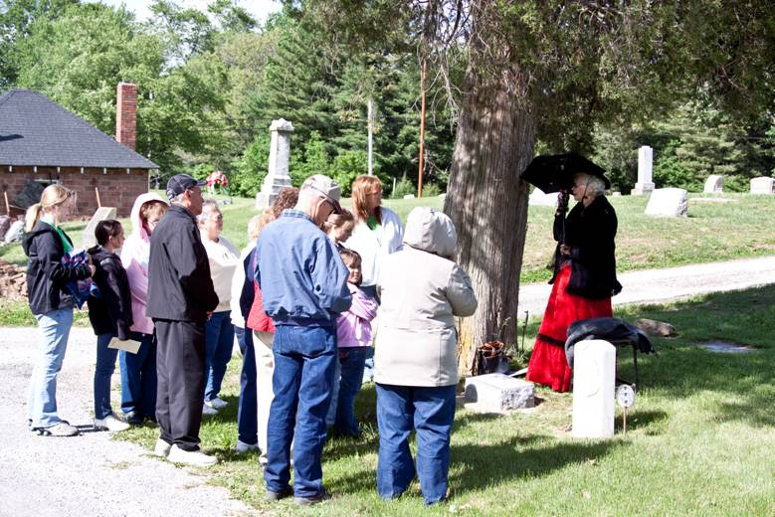
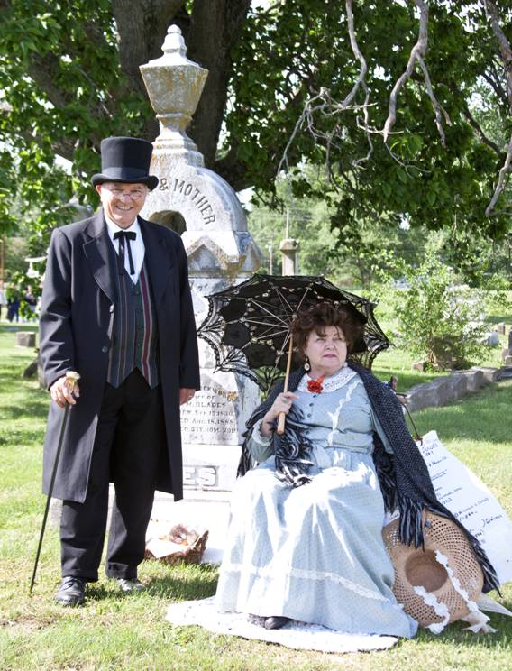

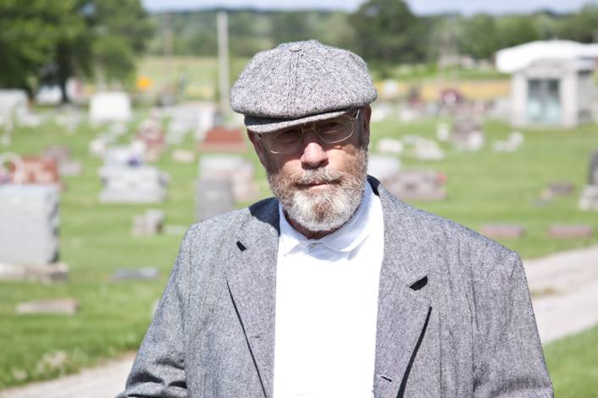

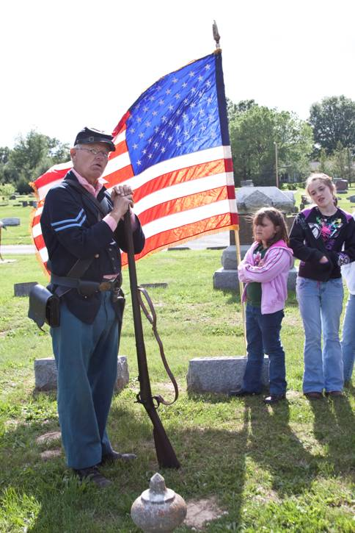

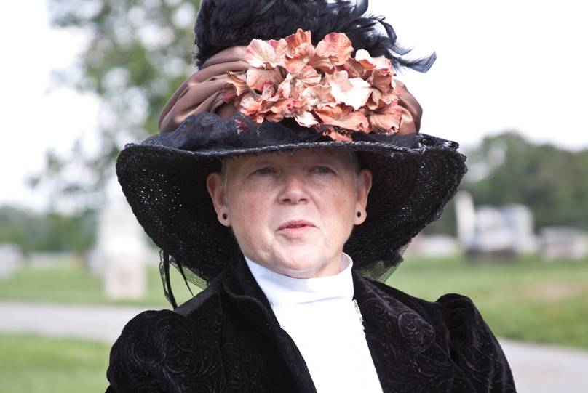
Photos by Marty Cox

