Presents:
Western European Vital Records
by Michelle Doutrich

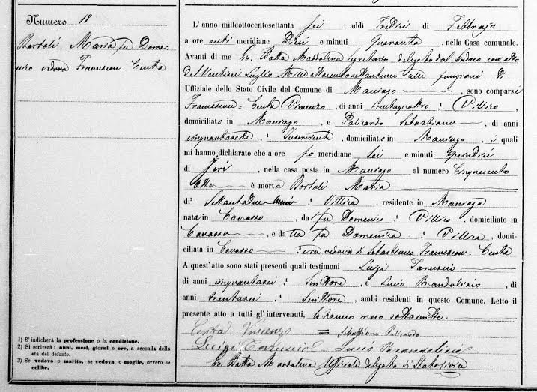

Please join us!

July 9, 2016 at 1:30 p.m.

Stroh Ranch Fire Station: 19310 Stroh Road, Parker

All are welcome and presentation is free to the public!
PGS meets every 2nd Saturday of the month. Can’t join us this month? Save the Date for August 13 when we will present: 1890 Census Replacement Records by Deena Carson..

